Team,

I wanted to give the suppliers below information but it looks like shown on attached. What’s the best way to provide supporting details to suppliers during tender? Can you send below to the invited suppliers in better understanding format?

***
Hello there,

This is to give more details on the RFQ scope.

1. Site and Work Location
The services may be performed outside of Ulaanbaatar. The intent is that the work be undertaken remotely from the Service Provider's offices, provided that all contractual requirements, communication arrangements, confidentiality obligations, and deliverables are met in accordance with the requirements.
2. Relevant Datasets
The successful bidder will be provided with the datasets required to complete the scope of work. These include:

ID | Tenement | Prospect | Exploration works | Unit | Volume | Year | Data File
1 | Manakht (MV006708) | Manakht West | Geological outcrop mapping | Observation point | 364 | 2022 | MT_MTW_Geol_MappingFieldLedger
2 | Manakht (MV006708) | Manakht West | Geological outcrop mapping | Observation point | - | 2024 | Unknown
3 | Manakht (MV006708) | Manakht West | Structural field observation | Observation point | 42 | 2024 | MT_MTW_Geol_StructureFieldObserv
4 | Manakht (MV006708) | Manakht West | Pethrographic analysis | Sample | 12 | 2022 | 004_Mineralogy
5 | Manakht (MV006708) | Manakht West | Geochemistry rock-chip sampling | Sample | 36 |  | MT_MTW_Geoc_RocksampleAssayP
6 | Manakht (MV006708) | Manakht West | Geochemistry soil sampling | Sample | 841 | 2015 | MT_MTW_Geoc_SoilAssayP_2015
7 | Manakht (MV006708) | Manakht West | Geochronology/Age-dating | Sample | 4 | 2022 | MT_MTW_Geoc_GeochronSampleP
8 | Manakht (MV006708) | Manakht West | Diamond drilling | meter | 1,058.3 | 2024 | Drilling data (CSV spreadsheet: Collar, survey, lith, min, alt, structure, vein, multi-element assay data)
9 | Manakht (MV006708) | Manakht West | RC drilling | meter | 235 | 2018 | Drilling data (CSV spreadsheet: Collar, survey, lith, min, alt, structure, vein, multi-element assay data)
10 | Manakht (MV006708) | Whole tenement | Geophysics - Ground magnetic | Hectares | 930 | 2014 | Line spacing 50 - 25m - to be clipped from the original dataset including RAW data
11 | Manakht (MV006708) | Whole tenement | Geophysics - Ground gravity | Hectares | 930 | 2025 | Grid 100 x 100m - To be clipped from the original dataset including RAW data
12 | Manakht (MV006708) | Whole tenement | Geophysics - Gradient-array IP | Hectares | 930 | 2005 | To be clipped from the original dataset including RAW data
13 | Manakht (MV006708) | Manakht West | Geophysics - DDIP | Line.km | 3 | 2016 | To be clipped from the original dataset including RAW data
14 | Manakht (MV006708) | Manakht West | Geophysics - Ground gravity | Hectares | 930 | 2024 | To be clipped from the original dataset including RAW data

The RFQ doesn’t specifically mention processing of the geophysical datasets, or completion of unconstrained or constrained geophysical modelling.
RAW data processing and uncontrained/contrained geophysical modelling are expected as part of the service.

The timeline is stated in the relevant SOW:

Milestones | August |  | September |  | October
 | 1st half | 2nd half | 1st half | 2nd half | 1st half | 2nd half
Tendering & Selection of Service Provider |  | +
Data Transfer |  |  | +
Technical Work Execution by the selected Service Provider |  |  |  | + | +
Final Deliverables Submission & Handover |  |  |  |  |  | +

A detailed data package will be made available following contract award.

Kind regards,
Oyu Tolgoi LLC
***

Regards,
Byra
FW: Oasis bug fix
From: Bayarjargal Baigalimaa (OT)
Sent: Tuesday, March 17, 2026 10:53 AM
To: Nandin-Erdene Chuluunbat (OT-UGUUMURGAVILUUD) <Nandin-ErdeneC@ot.mn>; Enkhtuul Davaadorj (OT) <EnkhtuulD@ot.mn>; OT OASIS SUPPORT (OT) <oasissupport@ot.mn>
Cc: OT Procurement Purchasing Team <OTProcurementPurchasingTeam@ot.mn>
Subject: Oasis bug fix

Hi,

Asuuldaa emaileer yavuulaarai gesnii daguu iishee bichij bna. Esvel oasis deerh alivaa asuudliig odoo zasah bolomjgui bolson uchir ug asuudald dedicated neesen teams group-iig leave hiisen yumuu? Bidend still zunduu asuudal tulgarch bgaa bolhoor hariltsaanii hamgiin amar hyalbar channel-aar hurdan shuurhai holbogdood yavbal Zugeer l sanagdaj bsan yum.

Hi team,
Manaihand bas ijil tustei asuudal bval gej bodood oruullaa. Heduulee alivaa oasis bug asuudliig neg dor buugnuulhiin tuld ene email deer loop-deed yavchih uu?

@Nandin-Erdene Chuluunbat (OT-UGUUMURGAVILUUD)
Uchigdur nuguu submit hiij bolohgui bsan bid summary Media pro-giin guy-tai yariad submit hiisen bolovch odoo orood harahaar miniii bichsenees shal ondoo bgaagiin uchriig yaaraltai shalguulj ugnu uu. Doorh bid deer IT zone-iig recommend hiigeed recommendation deer ni justification-ee bichsen atal odoo harahaar Izumi ruu 8K USD yavuulsan yum shig haragdaj bgaagiin uchir yu ve? Ene met awkward aldaanuud gargadgui bh deer ni ajillaad ugvul sain bna.

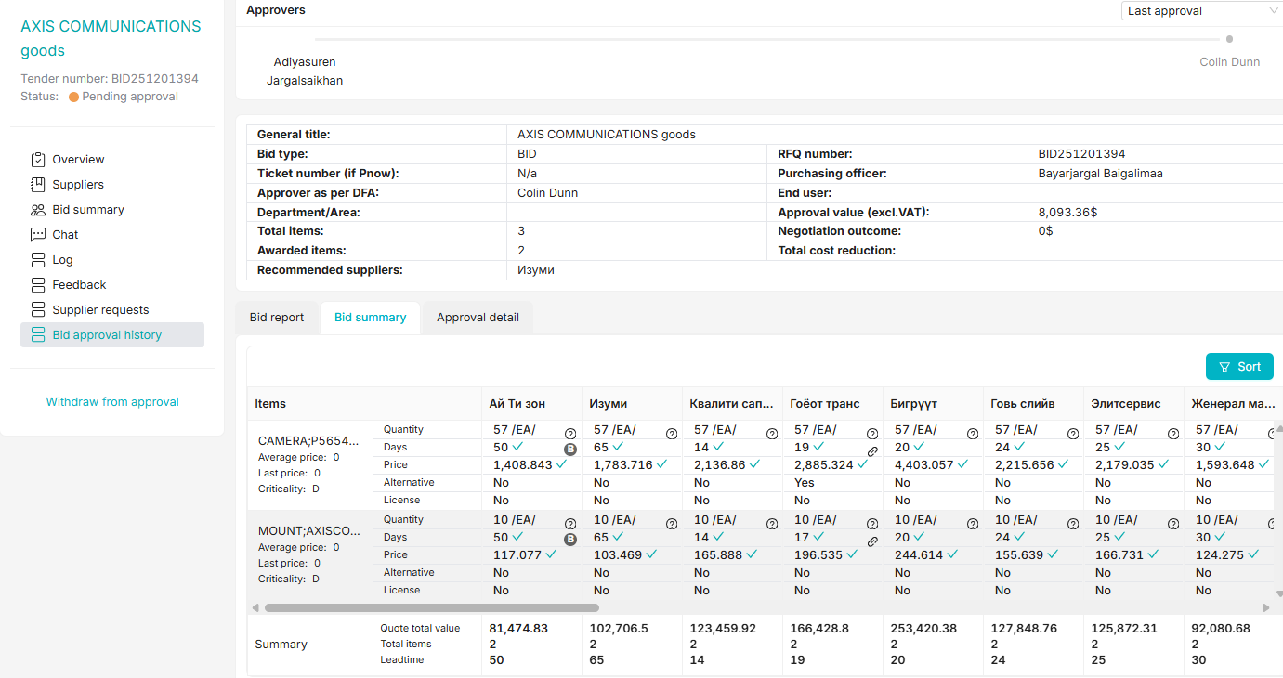

Best,
Byra
🔎⁠Please visit here to see any Pnow ticket status; or
🧮⁠Please visit here to find who is working on your PR
From: Bayarjargal Baigalimaa (OT) <bayarjargalba@ot.mn>
Sent: Tuesday, March 17, 2026 11:05 AM
To: Nandin-Erdene Chuluunbat (OT-UGUUMURGAVILUUD) <Nandin-ErdeneC@ot.mn>; Enkhtuul Davaadorj (OT) <EnkhtuulD@ot.mn>; OT OASIS SUPPORT (OT) <oasissupport@ot.mn>
Cc: OT Procurement Purchasing Team <OTProcurementPurchasingTeam@ot.mn>
Subject: RE: Oasis bug fix

Hi Oasis support team,

Ene ug ni 19K USD OEM, tegtel yagaad Hikmat ruu yavaad bgaa ve? Mun yagaad approval value ni 5.33USD gej haragdaad bgaa ve? Edgeer aldaanuudiig hurdan zasaad uguurei. Oasis aldaanaas bolood ene PR PO bolohgui zunduu udlaa.

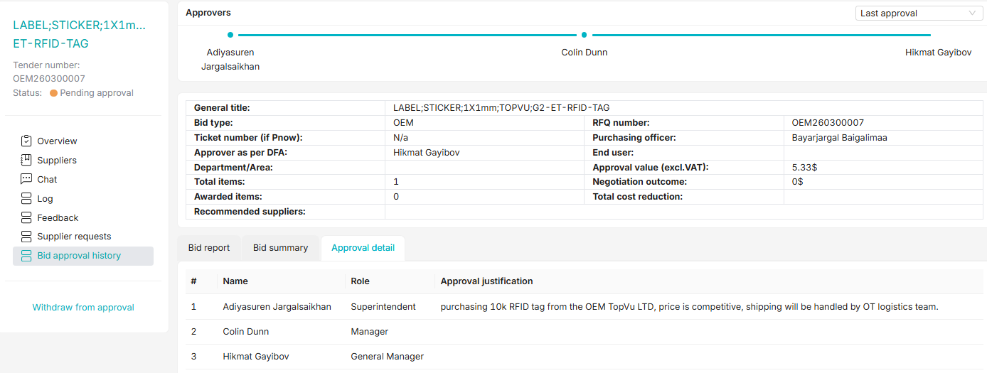

Best,
Byra
🔎⁠Please visit here to see any Pnow ticket status; or
🧮⁠Please visit here to find who is working on your PR
From: OT OASIS SUPPORT (OT) <oasissupport@ot.mn>
Sent: Tuesday, March 17, 2026 1:00 PM
To: Bayarjargal Baigalimaa (OT) <bayarjargalba@ot.mn>; Nandin-Erdene Chuluunbat (OT-UGUUMURGAVILUUD) <Nandin-ErdeneC@ot.mn>; Enkhtuul Davaadorj (OT) <EnkhtuulD@ot.mn>
Cc: OT Procurement Purchasing Team <OTProcurementPurchasingTeam@ot.mn>
Subject: RE: Oasis bug fix

Dear Bayarjargal,

Ene deer uuruu 19K USD gej oruulahdaa 19K MNT gej oruulsan baina. Ene deer MNT tootsood oruulahad zuv bolno. DFA huvid 5dhd zasvar orson talaar team deer bichsen, withdraw hiigeed dahiad yvuulahad boloohoor baina.

Sincerely,
OASIS Team
Contact: +976 75 778 800, Ext: 8888


From: Bayarjargal Baigalimaa (OT) <bayarjargalba@ot.mn>
Sent: Tuesday, March 17, 2026 1:26 PM
To: OT OASIS SUPPORT (OT) <oasissupport@ot.mn>; Nandin-Erdene Chuluunbat (OT-UGUUMURGAVILUUD) <Nandin-ErdeneC@ot.mn>; Enkhtuul Davaadorj (OT) <EnkhtuulD@ot.mn>
Cc: OT Procurement Purchasing Team <OTProcurementPurchasingTeam@ot.mn>
Subject: RE: Oasis bug fix

Hi,

19K USD gej dood taliih ni USD tsonhond oruulaad uuniig hurvuuleed 67M MNT gej haragdaj bsan. Tiimees terniihee daguu Colin ruu zuv ochood uchigdur batlagdsan. Colin deer harahad zuv bsan, harin today iim boltson bna. Tiimees yagaad iim bolson uchriig olood zasaad uguurei.

Best,
Byra
🔎⁠Please visit here to see any Pnow ticket status; or
🧮⁠Please visit here to find who is working on your PR
From: OT OASIS SUPPORT (OT) <oasissupport@ot.mn>
Sent: Tuesday, March 17, 2026 3:05 PM
To: Bayarjargal Baigalimaa (OT) <bayarjargalba@ot.mn>; Nandin-Erdene Chuluunbat (OT-UGUUMURGAVILUUD) <Nandin-ErdeneC@ot.mn>; Enkhtuul Davaadorj (OT) <EnkhtuulD@ot.mn>
Cc: OT Procurement Purchasing Team <OTProcurementPurchasingTeam@ot.mn>
Subject: RE: Oasis bug fix

Byra egch,

Eniig shalgalaa ene mun yalgaagui tanii ehnii yvuulsan history haragdaj baigaa ijil aldaa, ene deer ta zuv approval-r ni yvuulahiin tuld withdraw hiigeed dahiad yvuulahad bolohoor ym baina.

Sincerely,
Nandin
From: Bayarjargal Baigalimaa (OT) <bayarjargalba@ot.mn>
Sent: Thursday, March 19, 2026 3:52 PM
To: OT OASIS SUPPORT (OT) <oasissupport@ot.mn>; Nandin-Erdene Chuluunbat (OT-UGUUMURGAVILUUD) <Nandin-ErdeneC@ot.mn>; Enkhtuul Davaadorj (OT) <EnkhtuulD@ot.mn>
Cc: OT Procurement Purchasing Team <OTProcurementPurchasingTeam@ot.mn>
Subject: RE: Oasis bug fix

Hi

Oasis deer asuudal garsan uu? bid ntr haihaar yu ch garch irku tag bolchloo. Ingeed heden minut bolchloo. Gyals shalgaad uguurei. Thnks
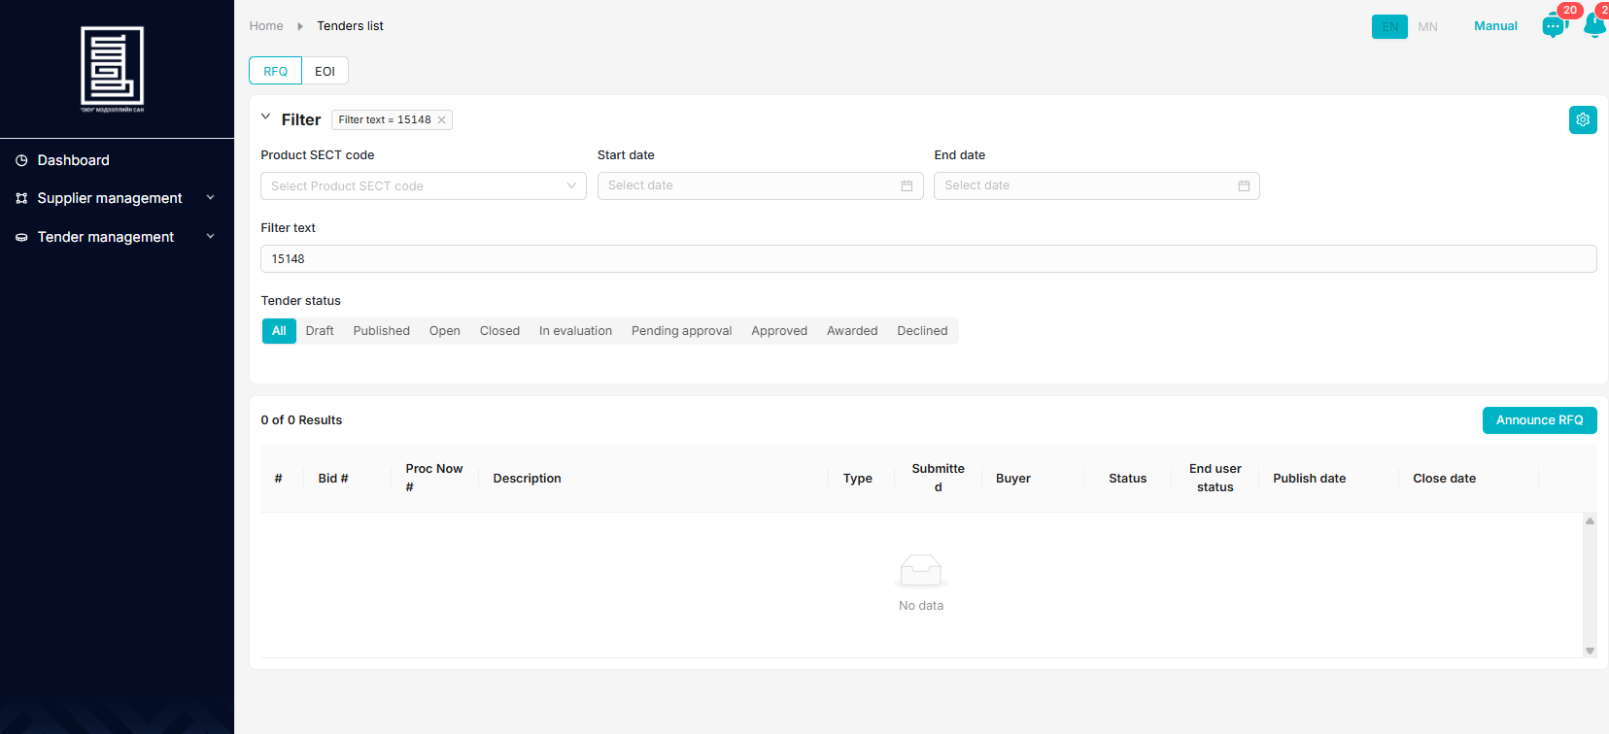
Best,
Byra

🔎⁠Please visit here to see any Pnow ticket status; or
🧮⁠Please visit here to find who is working on your PR
From: OT OASIS SUPPORT (OT) <oasissupport@ot.mn>
Sent: Thursday, March 19, 2026 4:39 PM
To: Bayarjargal Baigalimaa (OT) <bayarjargalba@ot.mn>; Nandin-Erdene Chuluunbat (OT-UGUUMURGAVILUUD) <Nandin-ErdeneC@ot.mn>; Enkhtuul Davaadorj (OT) <EnkhtuulD@ot.mn>
Cc: OT Procurement Purchasing Team <OTProcurementPurchasingTeam@ot.mn>
Subject: RE: Oasis bug fix

Hi,

Oasis asuudalgui baina. Turuun email ire hued shalgalaa, odoo bas zugeer bna.

Chiniih zugeer bolson uu?

Regards,

Tuul
From: Bayarjargal Baigalimaa (OT) <bayarjargalba@ot.mn>
Sent: Monday, March 23, 2026 5:37 PM
To: OT OASIS SUPPORT (OT) <oasissupport@ot.mn>; Nandin-Erdene Chuluunbat (OT-UGUUMURGAVILUUD) <Nandin-ErdeneC@ot.mn>; Enkhtuul Davaadorj (OT) <EnkhtuulD@ot.mn>
Cc: OT Procurement Purchasing Team <OTProcurementPurchasingTeam@ot.mn>
Subject: RE: Oasis bug fix

Hi Nandia,

BID260301126 ene RFQnii negotiationiig margaash 16 tsagt haahaar tohiruulaad uguurei pls. ingej soligdohod suppliert ni notification ochno tee? Margaash haagdhaar bolson shu gedeg ni?

Best,
Byra
🔎⁠Please visit here to see any Pnow ticket status; or
🧮⁠Please visit here to find who is working on your PR
From: OT OASIS SUPPORT (OT) <oasissupport@ot.mn>
Sent: Tuesday, March 24, 2026 9:25 AM
To: Bayarjargal Baigalimaa (OT) <bayarjargalba@ot.mn>; Nandin-Erdene Chuluunbat (OT-UGUUMURGAVILUUD) <Nandin-ErdeneC@ot.mn>; Enkhtuul Davaadorj (OT) <EnkhtuulD@ot.mn>
Cc: OT Procurement Purchasing Team <OTProcurementPurchasingTeam@ot.mn>
Subject: RE: Oasis bug fix

Dear Byra egch,

Ene garaar uurchilhuur email ochih bolomjgui ym.
Tegsen ch gesen uurchluh uu?

Sincerely,
Nandin
From: Bayarjargal Baigalimaa (OT) <bayarjargalba@ot.mn>
Sent: Tuesday, March 24, 2026 5:37 PM
To: OT OASIS SUPPORT (OT) <oasissupport@ot.mn>; Nandin-Erdene Chuluunbat (OT-UGUUMURGAVILUUD) <Nandin-ErdeneC@ot.mn>; Enkhtuul Davaadorj (OT) <EnkhtuulD@ot.mn>
Cc: OT Procurement Purchasing Team <OTProcurementPurchasingTeam@ot.mn>
Subject: RE: Oasis bug fix

Hi uuchirchie. Odoo hiigdeegui bga bol margaash 13 tsagt haahaar tohiruulaad uguurei pls. bi utsaar yariad sanuulchie suppliertaa. Thanks

Best,
Byra
🔎⁠Please visit here to see any Pnow ticket status; or
🧮⁠Please visit here to find who is working on your PR
From: OT OASIS SUPPORT (OT) <oasissupport@ot.mn>
Sent: Wednesday, March 25, 2026 10:41 AM
To: Bayarjargal Baigalimaa (OT) <bayarjargalba@ot.mn>; Nandin-Erdene Chuluunbat (OT-UGUUMURGAVILUUD) <Nandin-ErdeneC@ot.mn>; Enkhtuul Davaadorj (OT) <EnkhtuulD@ot.mn>
Cc: OT Procurement Purchasing Team <OTProcurementPurchasingTeam@ot.mn>
Subject: RE: Oasis bug fix

Dear Byra egch,

Ene deer negotiation haagdah hugatsaag unuuudriin 13:00 bolgoj uurchilluu. Garaar zassan uchraas supplier-uudad mail ochihgui bolohiig anhaarna uu.

Sincerely,
Nandin
From: Bayarjargal Baigalimaa (OT) <bayarjargalba@ot.mn>
Sent: Thursday, March 26, 2026 4:53 PM
To: OT OASIS SUPPORT (OT) <oasissupport@ot.mn>; Nandin-Erdene Chuluunbat (OT-UGUUMURGAVILUUD) <Nandin-ErdeneC@ot.mn>; Enkhtuul Davaadorj (OT) <EnkhtuulD@ot.mn>
Cc: OT Procurement Purchasing Team <OTProcurementPurchasingTeam@ot.mn>
Subject: RE: Oasis bug fix

Hi,

Ene bid deer supplier unee hyamdruulsan bolovch ter ni bid summary deer medegdkugees gadna negotiation Heseg deer 0$ gej garch ireed bgaag shalgaad uguurei. Ednii une anh bsan ni door haragdaj bgaagaas 6-16% unetei bsan, tegsen chin nuguu ? ni ch haragdku, gol ni negotiation dun haruulku bgaa yum.

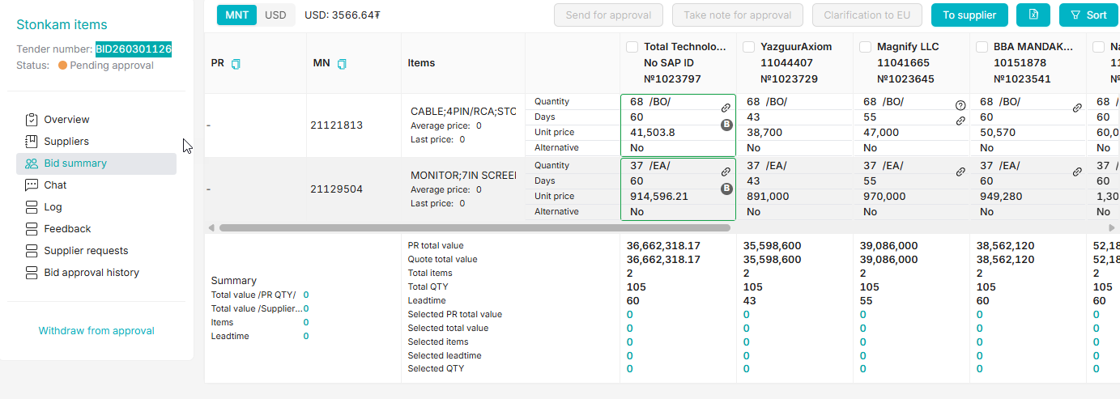

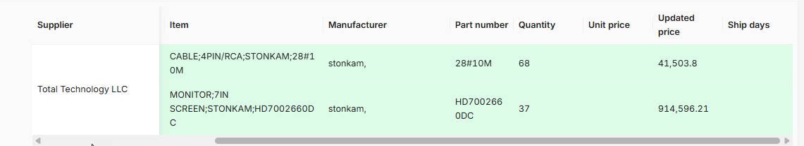

Best,
Byra
🔎⁠Please visit here to see any Pnow ticket status; or
🧮⁠Please visit here to find who is working on your PR
From: Bayarjargal Baigalimaa (OT) <bayarjargalba@ot.mn>
Sent: Monday, March 30, 2026 5:01 PM
To: OT OASIS SUPPORT (OT) <oasissupport@ot.mn>; Nandin-Erdene Chuluunbat (OT-UGUUMURGAVILUUD) <Nandin-ErdeneC@ot.mn>; Enkhtuul Davaadorj (OT) <EnkhtuulD@ot.mn>
Cc: OT Procurement Purchasing Team <OTProcurementPurchasingTeam@ot.mn>
Subject: RE: Oasis bug fix

Hi support team,

Save as draft ni ajilku bgaa yu ? ene bid deer end user ni songoltoo hiigeed comment oruulhaar zuvhun suuliin oruulsang ni hadgalaad umnuh songoltuud ni alga bolood bhaar ni songoltoo excel deer temdegleed iruulsen yum. tuuniih ni daguu bid summary deerees neg burchlen tuuj songood tailbar bicheed save as draft darsan chin odoo teriigee haanaas ch olku bolchloo. Ene uildliig 2 udaa hiisen, 2land ni yu ch hadgalagdsangui. Mun taken notes gedeg songolt ajilku bgaa yu? Bi hiisen ajlaa haanaas olj boloh ve? Eniig songosnoor maani sergeegeed haruulaad ugnu uu? dahij neg uidlee 3dahaa hiimeergui bnaa. Uneheer ih tsag avch bna.

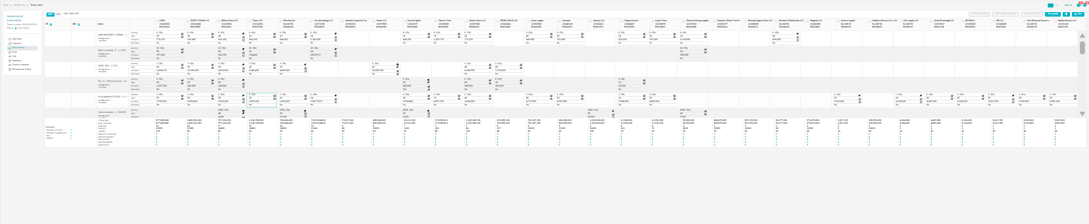

Best,
Byra
🔎⁠Please visit here to see any Pnow ticket status; or
🧮⁠Please visit here to find who is working on your PR
From: OT OASIS SUPPORT (OT) <oasissupport@ot.mn>
Sent: Monday, March 30, 2026 5:20 PM
To: Bayarjargal Baigalimaa (OT) <bayarjargalba@ot.mn>
Cc: OT Procurement Purchasing Team <OTProcurementPurchasingTeam@ot.mn>
Subject: RE: Oasis bug fix

Byra egch,

Ene option-g hereglej uzsen uu?

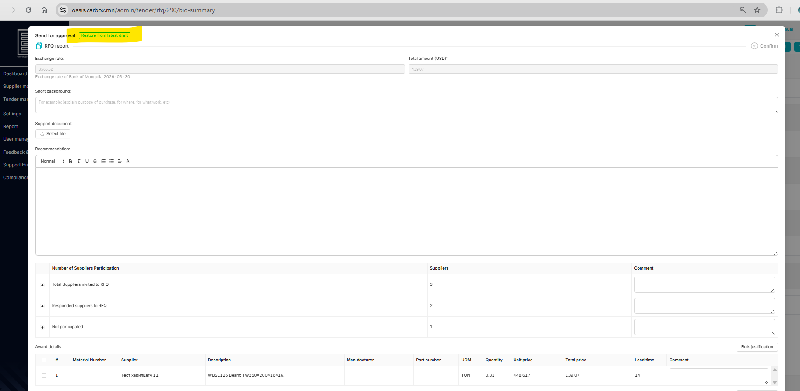

Sincerely,
Nandin
From: Mendsaikhan Munkhnasan (OT)
Sent: Tuesday, March 31, 2026 10:09 AM
To: OT OASIS SUPPORT (OT) <oasissupport@ot.mn>
Cc: OT Procurement Purchasing Team <OTProcurementPurchasingTeam@ot.mn>
Subject: RE: Oasis bug fix

Hi,

PO Inco term-g ni haanaas harah bilee? Ene gadaad vendor bga um

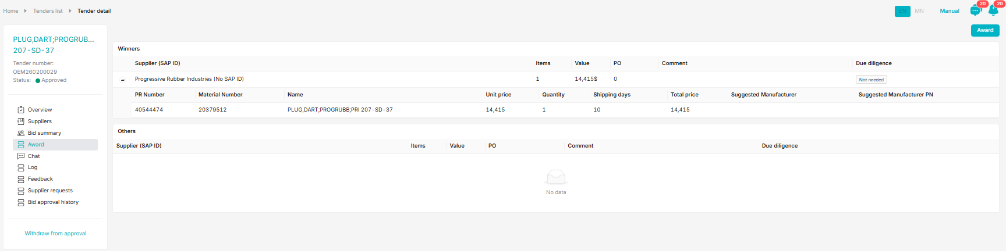

🔎 Please check out your ProcurementNow ticket status Pnow_v2 - Power BI here.
🧮 Need to know a responsible purchase officer for your SAP PR? PR - EU PR assignment - Power BI

Thanks.

Mendsaikhan
Officer - Purchasing | Procurement
M +976 99076319
From: Mendsaikhan Munkhnasan (OT) <MendsaikhanMun@ot.mn>
Sent: Tuesday, March 31, 2026 11:08 AM
To: OT OASIS SUPPORT (OT) <oasissupport@ot.mn>
Cc: OT Procurement Purchasing Team <OTProcurementPurchasingTeam@ot.mn>
Subject: RE: Oasis bug fix

Hi,

Tender zarlah gsen supplier list ni orj irdeggui ee ?

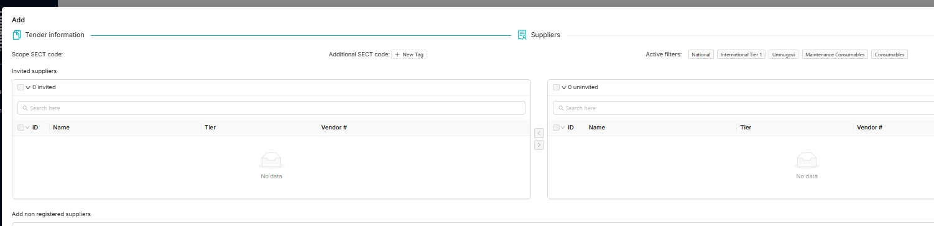

🔎 Please check out your ProcurementNow ticket status Pnow_v2 - Power BI here.
🧮 Need to know a responsible purchase officer for your SAP PR? PR - EU PR assignment - Power BI

Thanks.

Mendsaikhan
Officer - Purchasing | Procurement
M +976 99076319
From: OT OASIS SUPPORT (OT) <oasissupport@ot.mn>
Sent: Tuesday, March 31, 2026 1:40 PM
To: Mendsaikhan Munkhnasan (OT) <MendsaikhanMun@ot.mn>
Cc: OT Procurement Purchasing Team <OTProcurementPurchasingTeam@ot.mn>
Subject: RE: Oasis bug fix

Hi Mendee ah,

Ymar tender ve?

Sincerely,
Nandin
From: Ariunbolor Khuyagbaatar (OT) <AriunbolorK@ot.mn>
Sent: Tuesday, March 31, 2026 3:17 PM
To: OT OASIS SUPPORT (OT) <oasissupport@ot.mn>; Mendsaikhan Munkhnasan (OT) <MendsaikhanMun@ot.mn>
Cc: OT Procurement Purchasing Team <OTProcurementPurchasingTeam@ot.mn>
Subject: RE: Oasis bug fix

Hi Nandia,

Oasis deer OEM bicheed yavuulah gesen chin text n SHORT BACKGROUND heseg deer oruulsan text yag submit darah ued zambaraagui bolood bgaan bnaa. Eniig shalgaad zasaad ogoh bolomjtoi yu ?

Text n iim bolchood bgaa:

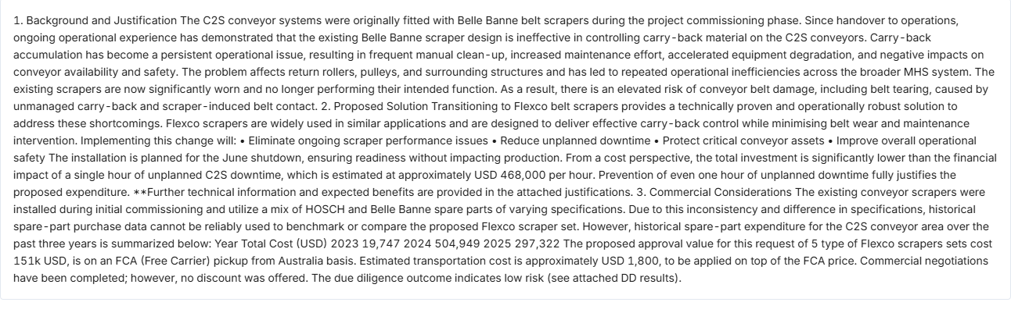

Ug n iim text bsn :
1. Background and Justification
The C2S conveyor systems were originally fitted with Belle Banne belt scrapers during the project commissioning phase. Since handover to operations, ongoing operational experience has demonstrated that the existing Belle Banne scraper design is ineffective in controlling carry-back material on the C2S conveyors.
Carry-back accumulation has become a persistent operational issue, resulting in frequent manual clean-up, increased maintenance effort, accelerated equipment degradation, and negative impacts on conveyor availability and safety. The problem affects return rollers, pulleys, and surrounding structures and has led to repeated operational inefficiencies across the broader MHS system.
The existing scrapers are now significantly worn and no longer performing their intended function. As a result, there is an elevated risk of conveyor belt damage, including belt tearing, caused by unmanaged carry-back and scraper-induced belt contact.

2. Proposed Solution
Transitioning to Flexco belt scrapers provides a technically proven and operationally robust solution to address these shortcomings. Flexco scrapers are widely used in similar applications and are designed to deliver effective carry-back control while minimising belt wear and maintenance intervention. Implementing this change will:
- Eliminate ongoing scraper performance issues
- Reduce unplanned downtime
- Protect critical conveyor assets
- Improve overall operational safety
The installation is planned for the June shutdown, ensuring readiness without impacting production.
From a cost perspective, the total investment is significantly lower than the financial impact of a single hour of unplanned C2S downtime, which is estimated at approximately USD 468,000 per hour. Prevention of even one hour of unplanned downtime fully justifies the proposed expenditure.
**Further technical information and expected benefits are provided in the attached justifications.

3. Commercial Considerations
The existing conveyor scrapers were installed during initial commissioning and utilize a mix of HOSCH and Belle Banne spare parts of varying specifications. Due to this inconsistency and difference in specifications, historical spare-part purchase data cannot be reliably used to benchmark or compare the proposed Flexco scraper set. However, historical spare-part expenditure for the C2S conveyor area over the past three years is summarized below:
Year | Total Cost (USD)
2023 | 19,747
2024 | 504,949
2025 | 297,322

The proposed approval value for this request of 5 type of Flexco scrapers sets cost 151k USD, is on an FCA (Free Carrier) pickup from Australia basis. Estimated transportation cost is approximately USD 1,800, to be applied on top of the FCA price.
Commercial negotiations have been completed; however, no discount was offered. The due diligence outcome indicates low risk (see attached DD results).

Regards,
Ariuka

Please use this link to see any Pnow ticket status🔎 ProcurementNow ticket status search
Please use this link to find PR assignments 🧮 SAP PR distribution status Click here
From: Bayarjargal Baigalimaa (OT) <bayarjargalba@ot.mn>
Sent: Tuesday, March 31, 2026 3:35 PM
To: OT OASIS SUPPORT (OT) <oasissupport@ot.mn>; Nandin-Erdene Chuluunbat (OT-UGUUMURGAVILUUD) <Nandin-ErdeneC@ot.mn>
Cc: OT Procurement Purchasing Team <OTProcurementPurchasingTeam@ot.mn>; Ariunbolor Khuyagbaatar (OT) <AriunbolorK@ot.mn>; Mendsaikhan Munkhnasan (OT) <MendsaikhanMun@ot.mn>
Subject: RE: Oasis bug fix

Hi support team,

Supplieraas end user price breakdown avmaar bgaan, tegeed clarification yavuulsan chin file havsargaj bolku bna genee. Ug ni clarification deer file havsargaj bolno gejiisen tee?
Herev hiigdeegui bol hezeenees file havsargaj boloh ve? Ene option bhgui uchraas ingeed emaileer nemelt medeelel avah, yavuulah shaardlaga uuseed bgaa ni uuruu actually not compliant solution yum.

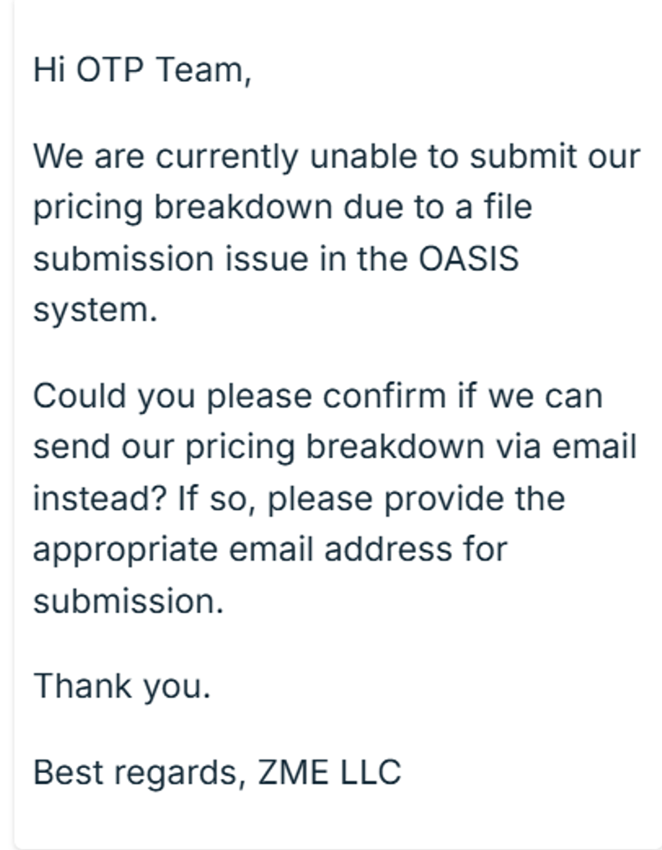

Best,
Byra
🔎⁠Please visit here to see any Pnow ticket status; or
🧮⁠Please visit here to find who is working on your PR
From: OT OASIS SUPPORT (OT) <oasissupport@ot.mn>
Sent: Tuesday, March 31, 2026 3:40 PM
To: Bayarjargal Baigalimaa (OT) <bayarjargalba@ot.mn>; Nandin-Erdene Chuluunbat (OT-UGUUMURGAVILUUD) <Nandin-ErdeneC@ot.mn>
Cc: OT Procurement Purchasing Team <OTProcurementPurchasingTeam@ot.mn>; Ariunbolor Khuyagbaatar (OT) <AriunbolorK@ot.mn>; Mendsaikhan Munkhnasan (OT) <MendsaikhanMun@ot.mn>
Subject: RE: Oasis bug fix

Dear Byra egch,

Clarification uyd file asuudalgui avch baigaa, iim uyd supplier-aa naashaa shuud holbuulaarai.

Sincerely,
Nandin
From: Mendsaikhan Munkhnasan (OT) <MendsaikhanMun@ot.mn>
Sent: Monday, April 6, 2026 11:07 AM
To: OT OASIS SUPPORT (OT) <oasissupport@ot.mn>; Bayarjargal Baigalimaa (OT) <bayarjargalba@ot.mn>; Nandin-Erdene Chuluunbat (OT-UGUUMURGAVILUUD) <Nandin-ErdeneC@ot.mn>
Cc: OT Procurement Purchasing Team <OTProcurementPurchasingTeam@ot.mn>; Ariunbolor Khuyagbaatar (OT) <AriunbolorK@ot.mn>
Subject: RE: Oasis bug fix

Hi, team

Clarification/Negotiation neeheer tuhain gazruud ruu e-mail notification ochij bga yu ? esul araas ni zaaval utasdaj harui ogoh talaar heleh yostoi yu?

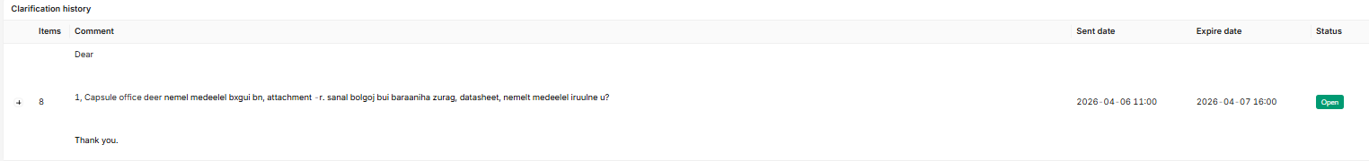

🔎 Please check out your ProcurementNow ticket status Pnow_v2 - Power BI here.
🧮 Need to know a responsible purchase officer for your SAP PR? PR - EU PR assignment - Power BI

Thanks.

Mendsaikhan
Officer - Purchasing | Procurement
M +976 99076319
From: OT OASIS SUPPORT (OT) <oasissupport@ot.mn>
Sent: Monday, April 6, 2026 11:58 AM
To: Mendsaikhan Munkhnasan (OT) <MendsaikhanMun@ot.mn>; Bayarjargal Baigalimaa (OT) <bayarjargalba@ot.mn>; Nandin-Erdene Chuluunbat (OT-UGUUMURGAVILUUD) <Nandin-ErdeneC@ot.mn>
Cc: OT Procurement Purchasing Team <OTProcurementPurchasingTeam@ot.mn>; Ariunbolor Khuyagbaatar (OT) <AriunbolorK@ot.mn>
Subject: RE: Oasis bug fix

Dear Mendee ah,

Ene anhnaasaa ymar ch asuudalgui ochij bgaa

Sincerely,
Nandin
From: Mendsaikhan Munkhnasan (OT) <MendsaikhanMun@ot.mn>
Sent: Monday, April 6, 2026 5:45 PM
To: OT OASIS SUPPORT (OT) <oasissupport@ot.mn>; Bayarjargal Baigalimaa (OT) <bayarjargalba@ot.mn>; Nandin-Erdene Chuluunbat (OT-UGUUMURGAVILUUD) <Nandin-ErdeneC@ot.mn>
Cc: OT Procurement Purchasing Team <OTProcurementPurchasingTeam@ot.mn>; Ariunbolor Khuyagbaatar (OT) <AriunbolorK@ot.mn>
Subject: RE: Oasis bug fix

Hi, Team

Ene odoo open bga Clarification ni supplier-t omnohuud ni haragdahgu, harui ogj chadaagui ged bgan. Bi 2-3 uda neejin. Ene final tul haagdahaas ni omno supplier-tai holbogdood harui avah deer demjleg uzuulne u , pls?

Tender number: BID260101291

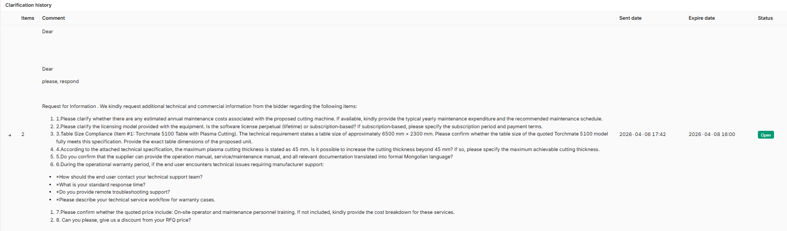

🔎 Please check out your ProcurementNow ticket status Pnow_v2 - Power BI here.
🧮 Need to know a responsible purchase officer for your SAP PR? PR - EU PR assignment - Power BI

Thanks.

Mendsaikhan
Officer - Purchasing | Procurement
M +976 99076319
From: Bayarjargal Baigalimaa (OT) <bayarjargalba@ot.mn>
Sent: Tuesday, April 7, 2026 6:15 PM
To: Mendsaikhan Munkhnasan (OT) <MendsaikhanMun@ot.mn>; OT OASIS SUPPORT (OT) <oasissupport@ot.mn>; Nandin-Erdene Chuluunbat (OT-UGUUMURGAVILUUD) <Nandin-ErdeneC@ot.mn>
Cc: OT Procurement Purchasing Team <OTProcurementPurchasingTeam@ot.mn>; Ariunbolor Khuyagbaatar (OT) <AriunbolorK@ot.mn>
Subject: RE: Oasis bug fix

Hi team,

Approval pending bgaa RFQnuud gadnaasaa Ariba shig hen deer pending bgaa ni haragddag bolgood ugch bolhu? Tehgui bolhoor neg burchlen neej orood harahaar tsag avaad bgaa yum. bayarlalaa

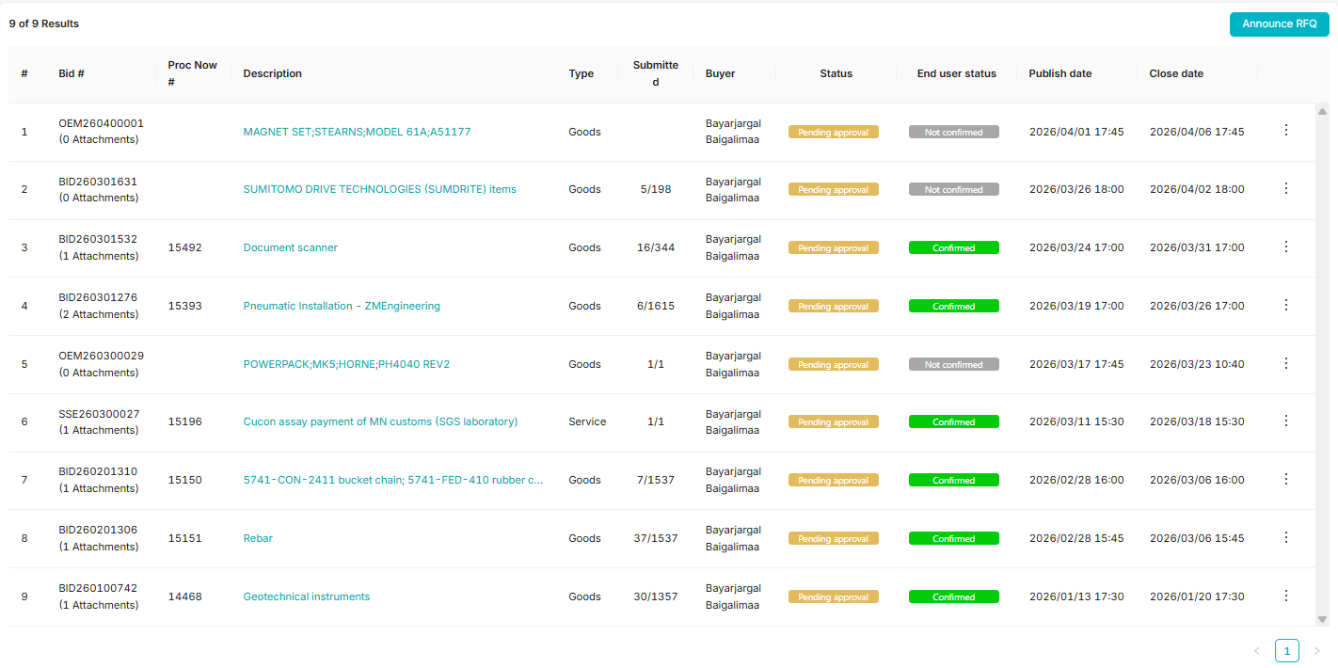

Best,
Byra
🔎⁠Please visit here to see any Pnow ticket status; or
🧮⁠Please visit here to find who is working on your PR
From: Ariunbolor Khuyagbaatar (OT) <AriunbolorK@ot.mn>
Sent: Thursday, April 9, 2026 2:19 PM
To: OT OASIS SUPPORT (OT) <oasissupport@ot.mn>; Nandin-Erdene Chuluunbat (OT-UGUUMURGAVILUUD) <Nandin-ErdeneC@ot.mn>
Cc: OT Procurement Purchasing Team <OTProcurementPurchasingTeam@ot.mn>
Subject: RE: Oasis bug fix

Hi Nandia,

BID260200847 deer Supplier ug n discounted une-ee oruulsan geed bnaa, gehdee nadad huuchin uniin medeelel n haargddagguie yah vee? Shalgaad ogooch please

Regards,
Ariuka

Please use this link to see any Pnow ticket status🔎 ProcurementNow ticket status search
Please use this link to find PR assignments 🧮 SAP PR distribution status Click here
From: Bayarjargal Baigalimaa (OT) <bayarjargalba@ot.mn>
Sent: Thursday, April 9, 2026 3:41 PM
To: Ariunbolor Khuyagbaatar (OT) <AriunbolorK@ot.mn>; OT OASIS SUPPORT (OT) <oasissupport@ot.mn>; Nandin-Erdene Chuluunbat (OT-UGUUMURGAVILUUD) <Nandin-ErdeneC@ot.mn>
Cc: OT Procurement Purchasing Team <OTProcurementPurchasingTeam@ot.mn>
Subject: RE: Oasis bug fix

Hi oasis team,

Tender deer supplieruudaas irsen messagenii deer bgaa forward deer darahaar ene ni tuhain bid deer reviewer-eer bgaa end user-uuded haragddag gej oilgoj bolhu? Ene tovchnii uureg tiimuu?

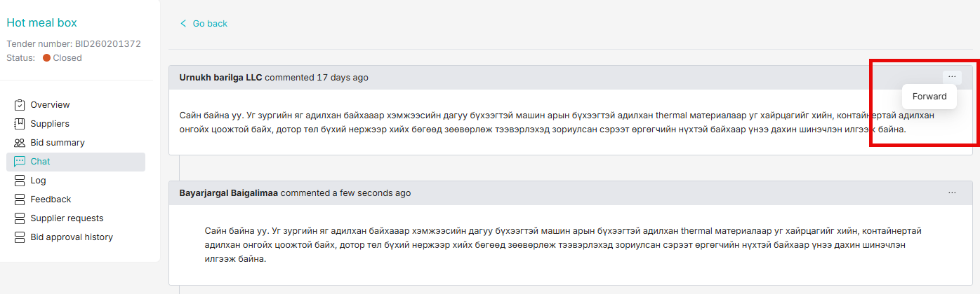

Best,
Byra
🔎⁠Please visit here to see any Pnow ticket status; or
🧮⁠Please visit here to find who is working on your PR
From: Bayarjargal Baigalimaa (OT) <bayarjargalba@ot.mn>
Sent: Thursday, April 9, 2026 4:05 PM
To: Ariunbolor Khuyagbaatar (OT) <AriunbolorK@ot.mn>; OT OASIS SUPPORT (OT) <oasissupport@ot.mn>; Nandin-Erdene Chuluunbat (OT-UGUUMURGAVILUUD) <Nandin-ErdeneC@ot.mn>
Cc: OT Procurement Purchasing Team <OTProcurementPurchasingTeam@ot.mn>
Subject: RE: Oasis bug fix

Hi team,

Ene buten haragdahgui bgaa textiig yaj harhu? Ingeed ih text irheer teriig ni buten unshij chadku bolchood bgaan.

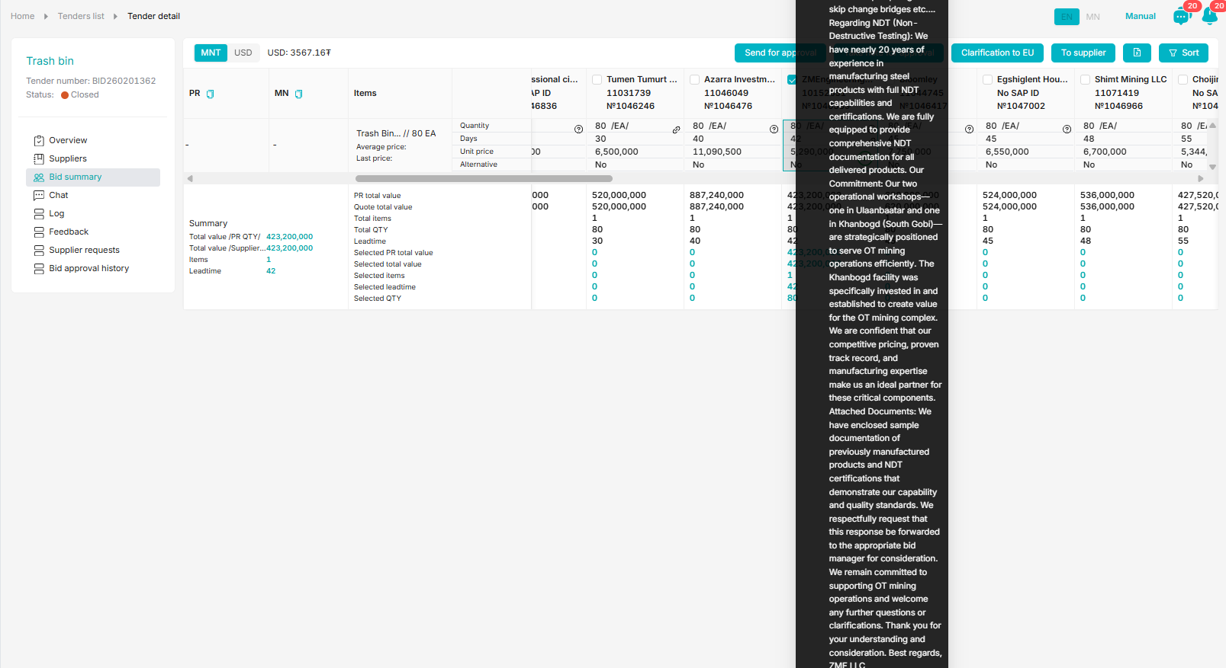

Best,
Byra
🔎⁠Please visit here to see any Pnow ticket status; or
🧮⁠Please visit here to find who is working on your PR
From: Bayarjargal Baigalimaa (OT) <bayarjargalba@ot.mn>
Sent: Thursday, April 9, 2026 5:48 PM
To: Ariunbolor Khuyagbaatar (OT) <AriunbolorK@ot.mn>; OT OASIS SUPPORT (OT) <oasissupport@ot.mn>; Nandin-Erdene Chuluunbat (OT-UGUUMURGAVILUUD) <Nandin-ErdeneC@ot.mn>
Cc: OT Procurement Purchasing Team <OTProcurementPurchasingTeam@ot.mn>
Subject: RE: Oasis bug fix
Importance: High

Hi NAndia,

Ene OEM-iig 3 honogoor zarlamaar bgaan, tegsen chin oasis honogoo buuruulj bolku nemj l boloh optiontoi bgaad bhiin. Yaaraltai shalgaad ugnu uu. thanks

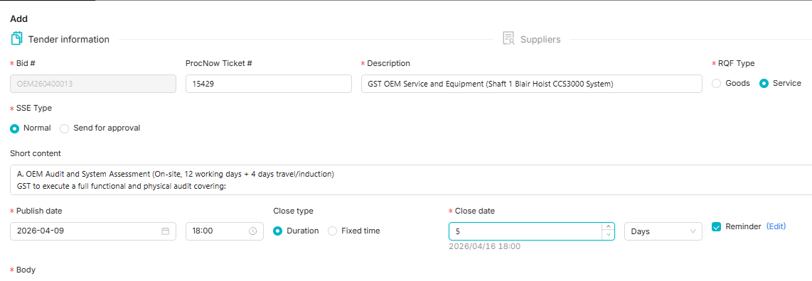

Best,
Byra
🔎⁠Please visit here to see any Pnow ticket status; or
🧮⁠Please visit here to find who is working on your PR
From: OT OASIS SUPPORT (OT)
Sent: Thursday, April 9, 2026 5:59 PM
To: Bayarjargal Baigalimaa (OT) <bayarjargalba@ot.mn>; Ariunbolor Khuyagbaatar (OT) <AriunbolorK@ot.mn>; Nandin-Erdene Chuluunbat (OT-UGUUMURGAVILUUD) <Nandin-ErdeneC@ot.mn>
Cc: OT Procurement Purchasing Team <OTProcurementPurchasingTeam@ot.mn>
Subject: RE: Oasis bug fix

Hi Byra egch,

Duration uyd dood tal ni 5 honog gej system deer tohiruulsan baigaa, ymar ch tender uyd default hamgiin baga honog ni 5 honog baina. Harin ta duration-aaraa 5-s baga honogoor zarlaj bolnoo

Sincerely,
Nandin
From: OT OASIS SUPPORT (OT) <oasissupport@ot.mn>
Sent: Thursday, April 9, 2026 6:01 PM
To: Bayarjargal Baigalimaa (OT) <bayarjargalba@ot.mn>; Ariunbolor Khuyagbaatar (OT) <AriunbolorK@ot.mn>; Nandin-Erdene Chuluunbat (OT-UGUUMURGAVILUUD) <Nandin-ErdeneC@ot.mn>
Cc: OT Procurement Purchasing Team <OTProcurementPurchasingTeam@ot.mn>
Subject: RE: Oasis bug fix

Sorry fixed-eeree zarlaj bolno geh gej baisan ym
From: Mendsaikhan Munkhnasan (OT) <MendsaikhanMun@ot.mn>
Sent: Monday, April 20, 2026 1:36 PM
To: OT OASIS SUPPORT (OT) <oasissupport@ot.mn>; Bayarjargal Baigalimaa (OT) <bayarjargalba@ot.mn>; Ariunbolor Khuyagbaatar (OT) <AriunbolorK@ot.mn>; Nandin-Erdene Chuluunbat (OT-UGUUMURGAVILUUD) <Nandin-ErdeneC@ot.mn>
Cc: OT Procurement Purchasing Team <OTProcurementPurchasingTeam@ot.mn>
Subject: RE: Oasis bug fix

Hi,

file n neegdehgu bhiin shalgaad uguuch, pls

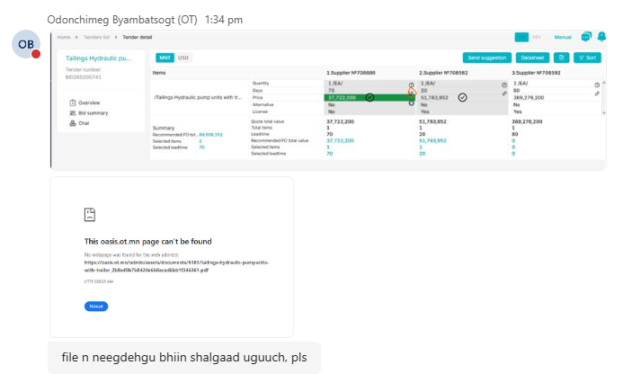

🔎 Please check out your ProcurementNow ticket status Pnow_v2 - Power BI here.
🧮 Need to know a responsible purchase officer for your SAP PR? PR - EU PR assignment - Power BI

Thanks.

Mendsaikhan
Officer - Purchasing | Procurement
M +976 99076319
From: Enkhbold Gendenjamts (OT) <EnkhboldG@ot.mn>
Sent: Monday, April 20, 2026 1:43 PM
To: OT OASIS SUPPORT (OT) <oasissupport@ot.mn>; Mendsaikhan Munkhnasan (OT) <MendsaikhanMun@ot.mn>; Bayarjargal Baigalimaa (OT) <bayarjargalba@ot.mn>; Ariunbolor Khuyagbaatar (OT) <AriunbolorK@ot.mn>; Nandin-Erdene Chuluunbat (OT-UGUUMURGAVILUUD) <Nandin-ErdeneC@ot.mn>
Cc: OT Procurement Purchasing Team <OTProcurementPurchasingTeam@ot.mn>
Subject: RE: Oasis bug fix

File neegdehgui baina bas nego hiiheer supplier talaas unee oruulhaar datasheet gesen aldaa zaagaad bolkui bn gene.

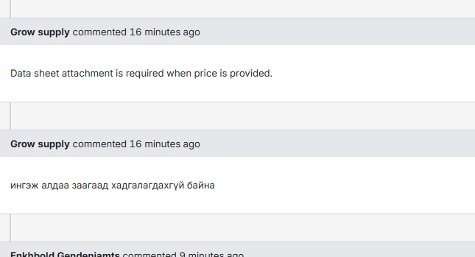
From: Ariunbolor Khuyagbaatar (OT) <AriunbolorK@ot.mn>
Sent: Monday, April 20, 2026 1:46 PM
To: Enkhbold Gendenjamts (OT) <EnkhboldG@ot.mn>; OT OASIS SUPPORT (OT) <oasissupport@ot.mn>; Mendsaikhan Munkhnasan (OT) <MendsaikhanMun@ot.mn>; Bayarjargal Baigalimaa (OT) <bayarjargalba@ot.mn>; Nandin-Erdene Chuluunbat (OT-UGUUMURGAVILUUD) <Nandin-ErdeneC@ot.mn>
Cc: OT Procurement Purchasing Team <OTProcurementPurchasingTeam@ot.mn>
Subject: RE: Oasis bug fix

Hi ,

Minii bas BDS deerh attachment neegdehgui bn

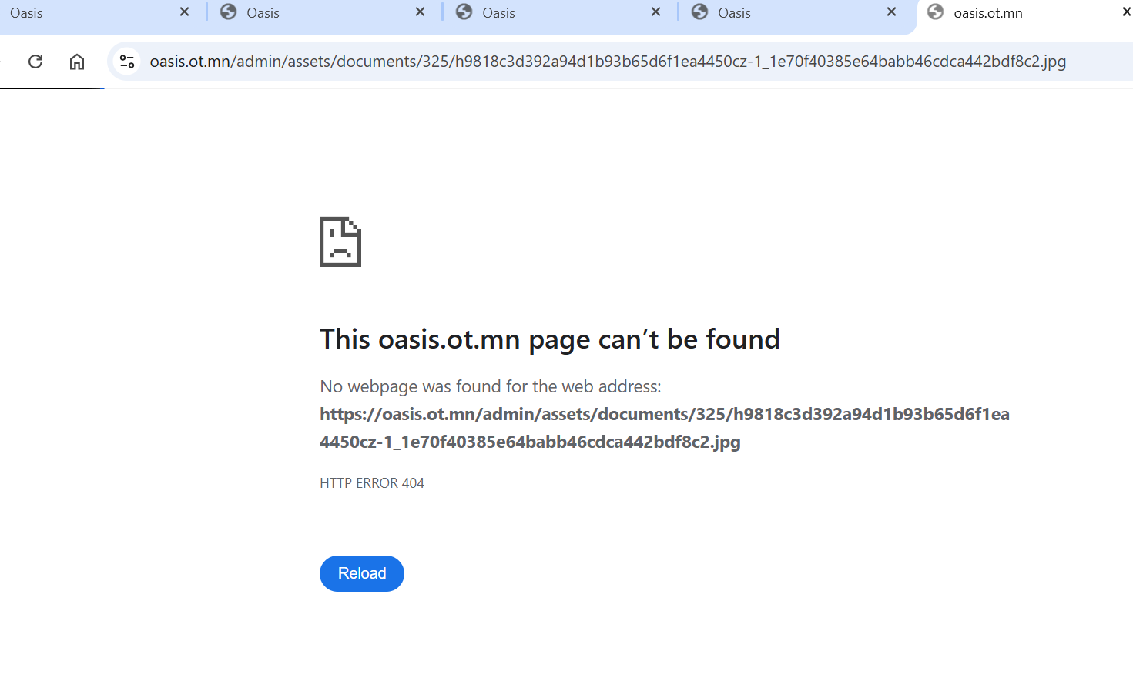

Regards,
Ariuka

Please use this link to see any Pnow ticket status🔎 ProcurementNow ticket status search
Please use this link to find PR assignments 🧮 SAP PR distribution status Click here
From: OT OASIS SUPPORT (OT) <oasissupport@ot.mn>
Sent: Monday, April 20, 2026 2:34 PM
To: Ariunbolor Khuyagbaatar (OT) <AriunbolorK@ot.mn>; Enkhbold Gendenjamts (OT) <EnkhboldG@ot.mn>; Mendsaikhan Munkhnasan (OT) <MendsaikhanMun@ot.mn>; Bayarjargal Baigalimaa (OT) <bayarjargalba@ot.mn>; Nandin-Erdene Chuluunbat (OT-UGUUMURGAVILUUD) <Nandin-ErdeneC@ot.mn>
Cc: OT Procurement Purchasing Team <OTProcurementPurchasingTeam@ot.mn>
Subject: RE: Oasis bug fix

Dear Ariuka egch,

Odoo bolson baigaa.

Sincerely,
OASIS Team
Contact: +976 75 778 800, Ext: 8888


From: Mendsaikhan Munkhnasan (OT)
Sent: Tuesday, April 21, 2026 4:24 PM
To: OT OASIS SUPPORT (OT) <oasissupport@ot.mn>; Ariunbolor Khuyagbaatar (OT) <AriunbolorK@ot.mn>; Enkhbold Gendenjamts (OT) <EnkhboldG@ot.mn>; Bayarjargal Baigalimaa (OT) <bayarjargalba@ot.mn>; Nandin-Erdene Chuluunbat (OT-UGUUMURGAVILUUD) <Nandin-ErdeneC@ot.mn>
Cc: OT Procurement Purchasing Team <OTProcurementPurchasingTeam@ot.mn>
Subject: RE: Oasis bug fix

Hi, Team

Onoodor Award hisni daraa nilulehgu geed PO-g ni cancelduulah huselt irsen. Ene award-g butsaaj oor une ogson gazar ru PO-go gargah yamar bolomj bga ve?

7 honog bol ongorogu. Butsaah option bxgu , re-open l gej bgad bna aa.

🔎 Please check out your ProcurementNow ticket status Pnow_v2 - Power BI here.
🧮 Need to know a responsible purchase officer for your SAP PR? PR - EU PR assignment - Power BI

Thanks.

Mendsaikhan
Officer - Purchasing | Procurement
M +976 99076319
From: Mendsaikhan Munkhnasan (OT) <MendsaikhanMun@ot.mn>
Sent: Tuesday, April 21, 2026 6:27 PM
To: OT OASIS SUPPORT (OT) <oasissupport@ot.mn>; Ariunbolor Khuyagbaatar (OT) <AriunbolorK@ot.mn>; Enkhbold Gendenjamts (OT) <EnkhboldG@ot.mn>; Bayarjargal Baigalimaa (OT) <bayarjargalba@ot.mn>; Nandin-Erdene Chuluunbat (OT-UGUUMURGAVILUUD) <Nandin-ErdeneC@ot.mn>
Cc: OT Procurement Purchasing Team <OTProcurementPurchasingTeam@ot.mn>
Subject: RE: Oasis bug fix

Hi, Team

Bid summary, Bidder-s selection deer select all esul cheapest, higher price ged sort hij select hih option nemj ogno u? odoo bugdig ni 1,1-eer ni select hiih l bolomjtoi bna.

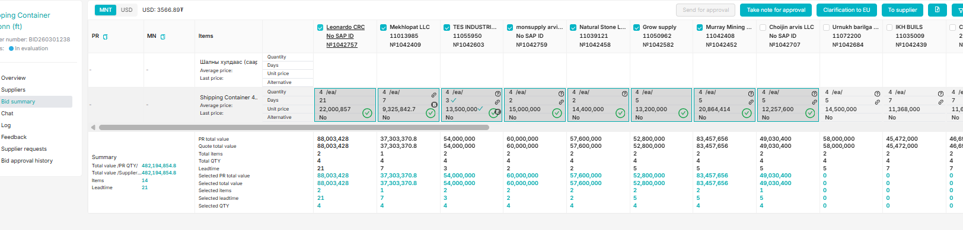
🔎 Please check out your ProcurementNow ticket status Pnow_v2 - Power BI here.
🧮 Need to know a responsible purchase officer for your SAP PR? PR - EU PR assignment - Power BI

Thanks.

Mendsaikhan
Officer - Purchasing | Procurement
M +976 99076319
From: OT OASIS SUPPORT (OT) <oasissupport@ot.mn>
Sent: Wednesday, April 22, 2026 10:47 AM
To: Mendsaikhan Munkhnasan (OT) <MendsaikhanMun@ot.mn>; Ariunbolor Khuyagbaatar (OT) <AriunbolorK@ot.mn>; Enkhbold Gendenjamts (OT) <EnkhboldG@ot.mn>; Bayarjargal Baigalimaa (OT) <bayarjargalba@ot.mn>; Nandin-Erdene Chuluunbat (OT-UGUUMURGAVILUUD) <Nandin-ErdeneC@ot.mn>
Cc: OT Procurement Purchasing Team <OTProcurementPurchasingTeam@ot.mn>
Subject: RE: Oasis bug fix

Dear Mendee ah,

Cheapest bolon select all hiij baigaa option-uud baigaa.

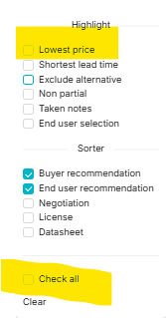

Sincerely,
OASIS Support Team
Contact: +976 75 778 800, Ext: 8888


From: Bayarjargal Baigalimaa (OT) <bayarjargalba@ot.mn>
Sent: Wednesday, April 22, 2026 5:44 PM
To: OT OASIS SUPPORT (OT) <oasissupport@ot.mn>; Mendsaikhan Munkhnasan (OT) <MendsaikhanMun@ot.mn>; Ariunbolor Khuyagbaatar (OT) <AriunbolorK@ot.mn>; Enkhbold Gendenjamts (OT) <EnkhboldG@ot.mn>; Nandin-Erdene Chuluunbat (OT-UGUUMURGAVILUUD) <Nandin-ErdeneC@ot.mn>
Cc: OT Procurement Purchasing Team <OTProcurementPurchasingTeam@ot.mn>
Subject: RE: Oasis bug fix

Hi team,

Tender zarlah gesen chin ingeed bh yum. ene yahaar ingej garch irdeg v e?

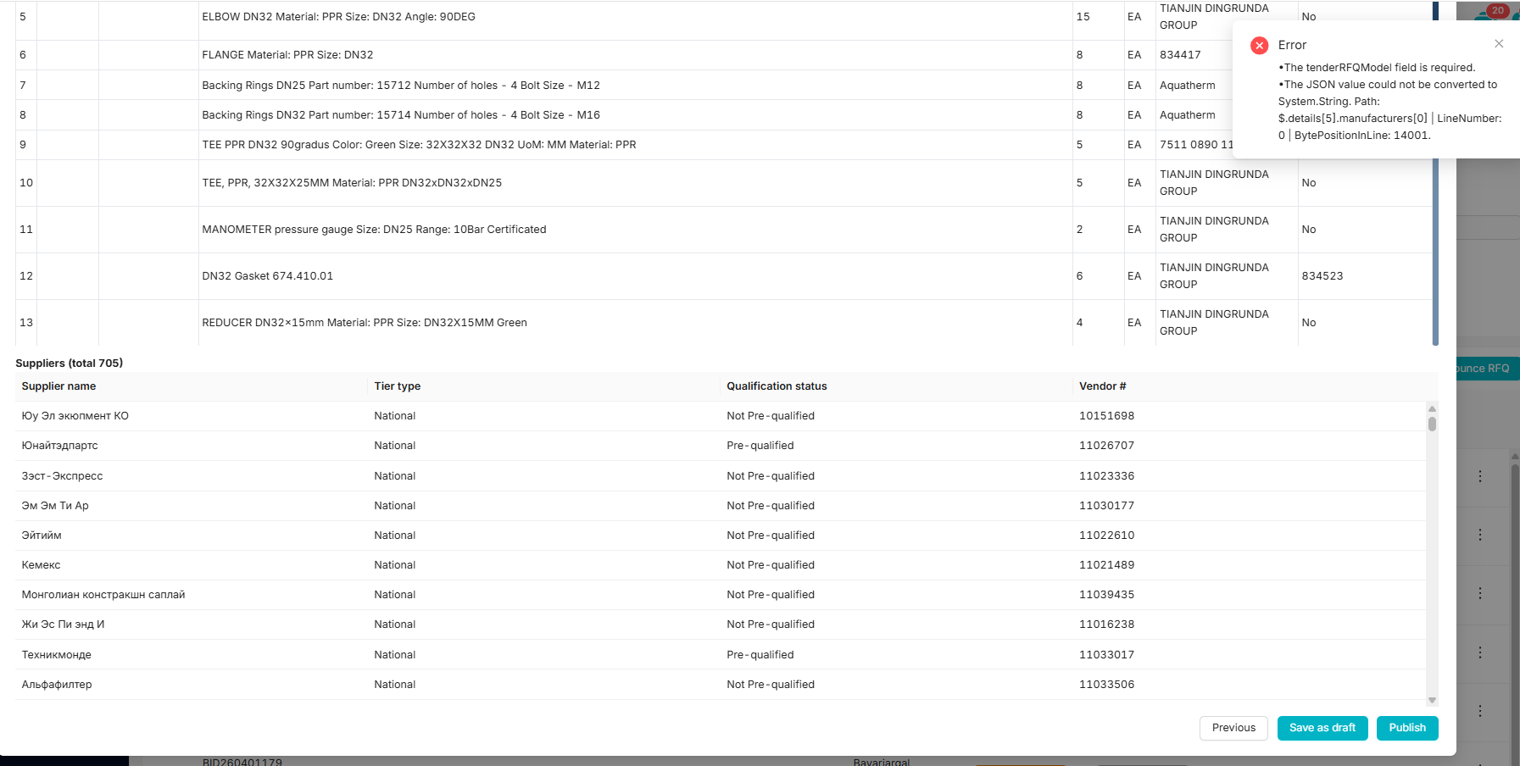

Best,
Byra
🔎⁠Please visit here to see any Pnow ticket status; or
🧮⁠Please visit here to find who is working on your PR
From: OT OASIS SUPPORT (OT) <oasissupport@ot.mn>
Sent: Wednesday, April 22, 2026 6:12 PM
To: Bayarjargal Baigalimaa (OT) <bayarjargalba@ot.mn>; Mendsaikhan Munkhnasan (OT) <MendsaikhanMun@ot.mn>; Ariunbolor Khuyagbaatar (OT) <AriunbolorK@ot.mn>; Enkhbold Gendenjamts (OT) <EnkhboldG@ot.mn>; Nandin-Erdene Chuluunbat (OT-UGUUMURGAVILUUD) <Nandin-ErdeneC@ot.mn>
Cc: OT Procurement Purchasing Team <OTProcurementPurchasingTeam@ot.mn>
Subject: RE: Oasis bug fix

Hi Byraa egchee,

Tender dugaar ni hed ve ? Manufacturer deer ni toon utga yvaad baigaa haragdaj baina, teriig zasaad bolchih baihaa.

Sincerely,
OASIS Team
Contact: +976 75 778 800, Ext: 8888


From: Sergelen Badarch (OT) <SergelenB@ot.mn>
Sent: Monday, April 27, 2026 1:42 PM
To: OT OASIS SUPPORT (OT) <oasissupport@ot.mn>; Bayarjargal Baigalimaa (OT) <bayarjargalba@ot.mn>; Mendsaikhan Munkhnasan (OT) <MendsaikhanMun@ot.mn>; Ariunbolor Khuyagbaatar (OT) <AriunbolorK@ot.mn>; Enkhbold Gendenjamts (OT) <EnkhboldG@ot.mn>; Nandin-Erdene Chuluunbat (OT-UGUUMURGAVILUUD) <Nandin-ErdeneC@ot.mn>
Cc: OT Procurement Purchasing Team <OTProcurementPurchasingTeam@ot.mn>
Subject: RE: Oasis bug fix

Dear Nandia and Tuul egch,

BID260201029-
Tires

Ene tenderiif 4,5 udaa recommendation bichij approval yavuullaa, approval yer yavahgui baina, shalgaad uguuch plz

BR,
Sergelen
From: Bayarjargal Baigalimaa (OT) <bayarjargalba@ot.mn>
Sent: Monday, April 27, 2026 2:50 PM
To: Sergelen Badarch (OT) <SergelenB@ot.mn>; OT OASIS SUPPORT (OT) <oasissupport@ot.mn>; Mendsaikhan Munkhnasan (OT) <MendsaikhanMun@ot.mn>; Ariunbolor Khuyagbaatar (OT) <AriunbolorK@ot.mn>; Enkhbold Gendenjamts (OT) <EnkhboldG@ot.mn>; Nandin-Erdene Chuluunbat (OT-UGUUMURGAVILUUD) <Nandin-ErdeneC@ot.mn>
Cc: OT Procurement Purchasing Team <OTProcurementPurchasingTeam@ot.mn>
Subject: RE: Oasis bug fix

Hi oasis team,

PR bolon material dugaaraar tender zarlah geheer orj irehgui yum, shalgaad ugnu uu.

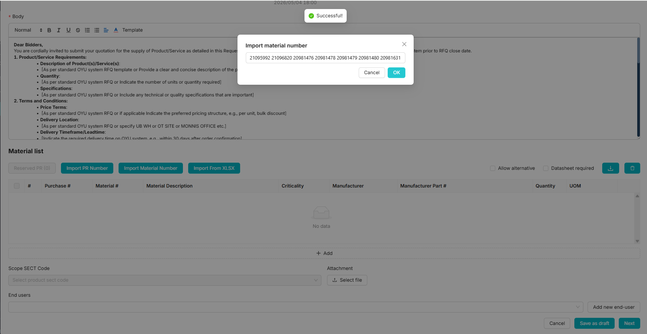

Best,
Byra
🔎⁠Please visit here to see any Pnow ticket status; or
🧮⁠Please visit here to find who is working on your PR
From: Mendsaikhan Munkhnasan (OT) <MendsaikhanMun@ot.mn>
Sent: Tuesday, April 28, 2026 11:17 AM
To: Bayarjargal Baigalimaa (OT) <bayarjargalba@ot.mn>; Sergelen Badarch (OT) <SergelenB@ot.mn>; OT OASIS SUPPORT (OT) <oasissupport@ot.mn>; Ariunbolor Khuyagbaatar (OT) <AriunbolorK@ot.mn>; Enkhbold Gendenjamts (OT) <EnkhboldG@ot.mn>; Nandin-Erdene Chuluunbat (OT-UGUUMURGAVILUUD) <Nandin-ErdeneC@ot.mn>
Cc: OT Procurement Purchasing Team <OTProcurementPurchasingTeam@ot.mn>
Subject: RE: Oasis bug fix

Hi, Team

Ene RFQ zarlahdaa Datasheet required gedeg option-g tick higed zaralsan. Gevch datasheet bxgu offer-ud orj irsen haragdaj bna. ene option ni datasheet zaaval havsargah yostoi , ene requirement gej oilgod bga. Zov u? yagad datasheet , file attachment bxgu une orj ireed bgag shalgaad ogno u?

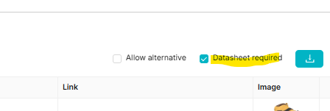

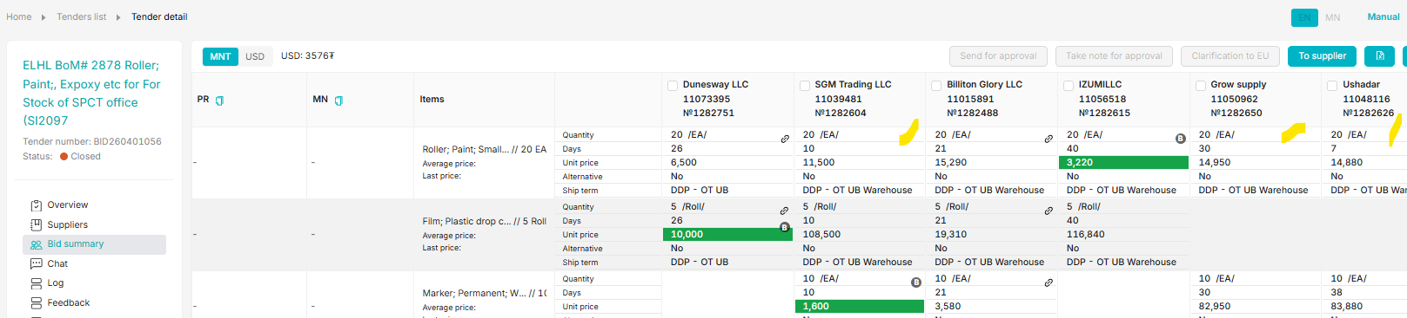

🔎 Please check out your ProcurementNow ticket status Pnow_v2 - Power BI here.
🧮 Need to know a responsible purchase officer for your SAP PR? PR - EU PR assignment - Power BI

Thanks.

Mendsaikhan
Officer - Purchasing | Procurement
M +976 99076319
From: Ariunbolor Khuyagbaatar (OT) <AriunbolorK@ot.mn>
Sent: Tuesday, April 28, 2026 4:11 PM
To: Mendsaikhan Munkhnasan (OT) <MendsaikhanMun@ot.mn>; Bayarjargal Baigalimaa (OT) <bayarjargalba@ot.mn>; Sergelen Badarch (OT) <SergelenB@ot.mn>; OT OASIS SUPPORT (OT) <oasissupport@ot.mn>; Enkhbold Gendenjamts (OT) <EnkhboldG@ot.mn>; Nandin-Erdene Chuluunbat (OT-UGUUMURGAVILUUD) <Nandin-ErdeneC@ot.mn>
Cc: OT Procurement Purchasing Team <OTProcurementPurchasingTeam@ot.mn>
Subject: RE: Oasis bug fix

Hi team,

EU-iig nemj bolohgui heveree bgaa yuymuu ? Hezee zasagdah bol? Adaa zaagaad nemdegdehgui bnaa.

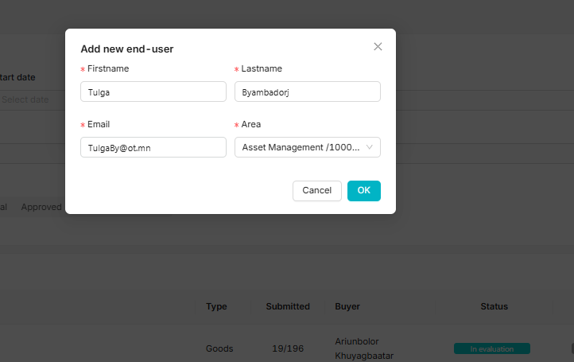

Regards,
Ariuka

Please use this link to see any Pnow ticket status🔎 ProcurementNow ticket status search
Please use this link to find PR assignments 🧮 SAP PR distribution status Click here
From: OT OASIS SUPPORT (OT) <oasissupport@ot.mn>
Sent: Wednesday, April 29, 2026 10:14 AM
To: Ariunbolor Khuyagbaatar (OT) <AriunbolorK@ot.mn>; Mendsaikhan Munkhnasan (OT) <MendsaikhanMun@ot.mn>; Bayarjargal Baigalimaa (OT) <bayarjargalba@ot.mn>; Sergelen Badarch (OT) <SergelenB@ot.mn>; Enkhbold Gendenjamts (OT) <EnkhboldG@ot.mn>; Nandin-Erdene Chuluunbat (OT-UGUUMURGAVILUUD) <Nandin-ErdeneC@ot.mn>
Cc: OT Procurement Purchasing Team <OTProcurementPurchasingTeam@ot.mn>
Subject: RE: Oasis bug fix

Hi Ari egch,

Ene bolson baih ystoi, odoo shalgaad uzeerei.

Sincerely,
OASIS Team
Contact: +976 75 778 800, Ext: 8888


From: Mendsaikhan Munkhnasan (OT) <MendsaikhanMun@ot.mn>
Sent: Friday, May 1, 2026 1:35 PM
To: OT OASIS SUPPORT (OT) <oasissupport@ot.mn>; Ariunbolor Khuyagbaatar (OT) <AriunbolorK@ot.mn>; Bayarjargal Baigalimaa (OT) <bayarjargalba@ot.mn>; Sergelen Badarch (OT) <SergelenB@ot.mn>; Enkhbold Gendenjamts (OT) <EnkhboldG@ot.mn>; Nandin-Erdene Chuluunbat (OT-UGUUMURGAVILUUD) <Nandin-ErdeneC@ot.mn>
Cc: OT Procurement Purchasing Team <OTProcurementPurchasingTeam@ot.mn>
Subject: RE: Oasis bug fix

Hi, Team

End-user -t supplier-n dugaar ni 7 bish 6 orontoi haragdaj bna gnee. Ingeheer nadad bolhor 7 orontoi haragdaad bga tul ali gazar gedeg ni todorhoi bish oilgomjgu bolj bna. iimd uunig zasaj ogno u?

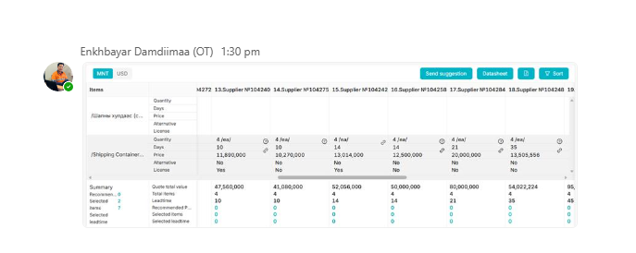

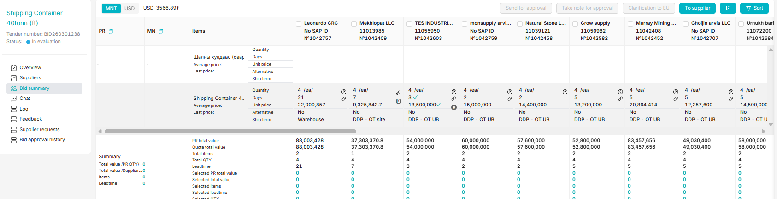

🔎 Please check out your ProcurementNow ticket status Pnow_v2 - Power BI here.
🧮 Need to know a responsible purchase officer for your SAP PR? PR - EU PR assignment - Power BI

Thanks.

Mendsaikhan
Officer - Purchasing | Procurement
M +976 99076319
From: Mendsaikhan Munkhnasan (OT)
Sent: Friday, May 8, 2026 8:48 AM
To: OT OASIS SUPPORT (OT) <oasissupport@ot.mn>; Nandin-Erdene Chuluunbat (OT-UGUUMURGAVILUUD) <Nandin-ErdeneC@ot.mn>
Cc: OT Procurement Purchasing Team <OTProcurementPurchasingTeam@ot.mn>
Subject: RE: Oasis bug fix

Hi, Team

morning

Une-g ni bagaas ni ih ruu ni sortlood haruldag bolgoh yamar bolomj bdin bol, bi haigad olohgu bna u, esul ugasa iim option bxgumu? Yagad uneteig ni ehend ni default-r harulad bga ve ?

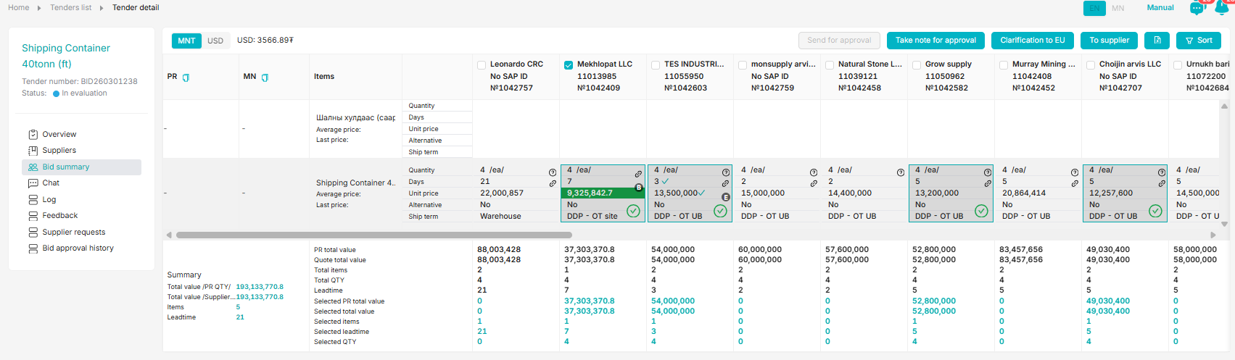

🔎 Please check out your ProcurementNow ticket status Pnow_v2 - Power BI here.
🧮 Need to know a responsible purchase officer for your SAP PR? PR - EU PR assignment - Power BI

Thanks.

Mendsaikhan
Officer - Purchasing | Procurement
M +976 99076319
From: Mendsaikhan Munkhnasan (OT) <MendsaikhanMun@ot.mn>
Sent: Friday, May 8, 2026 9:44 AM
To: OT OASIS SUPPORT (OT) <oasissupport@ot.mn>; Nandin-Erdene Chuluunbat (OT-UGUUMURGAVILUUD) <Nandin-ErdeneC@ot.mn>
Cc: OT Procurement Purchasing Team <OTProcurementPurchasingTeam@ot.mn>
Subject: RE: Oasis bug fix

Hi,

Supplier

Doorhi ali 1-r ni yabmar bna. Zarim ner ni angli mongol ni zorod confuse bolood bga tul alphabet, ner holihgu bolgoj ogno u?

Jishee ni doorh vendor 1 bolovch ner ni oor, oor haragdaj bga ni toorogdol uusgej bna.

- Egshiglent House
- Хант констракшн

Award deer

- BID summary dere latin alphabet ner ni English
- Award dere cyrillic alphabet ner ni Mongolian

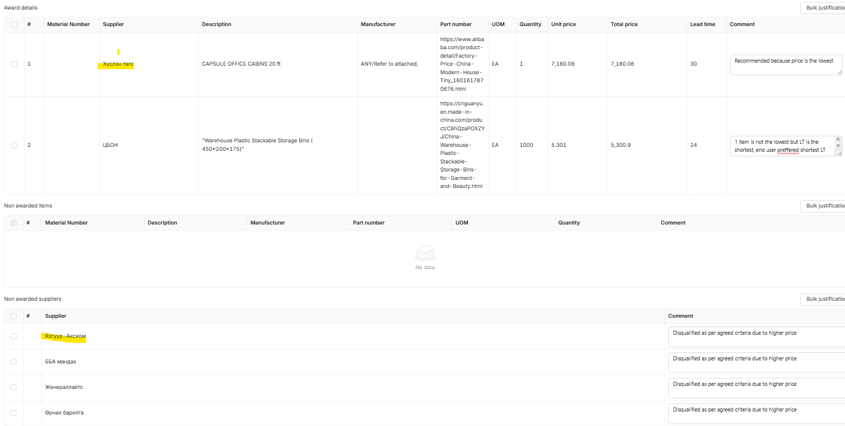
🔎 Please check out your ProcurementNow ticket status Pnow_v2 - Power BI here.
🧮 Need to know a responsible purchase officer for your SAP PR? PR - EU PR assignment - Power BI

Thanks.

Mendsaikhan
Officer - Purchasing | Procurement
M +976 99076319
From: OT OASIS SUPPORT (OT) <oasissupport@ot.mn>
Sent: Friday, May 8, 2026 10:20 AM
To: Mendsaikhan Munkhnasan (OT) <MendsaikhanMun@ot.mn>; Nandin-Erdene Chuluunbat (OT-UGUUMURGAVILUUD) <Nandin-ErdeneC@ot.mn>
Cc: OT Procurement Purchasing Team <OTProcurementPurchasingTeam@ot.mn>
Subject: RE: Oasis bug fix

Sain uu,

Tiim baina lee, Adiya yag doorkhi BID case-iig helsen, unuudur oroi update oruulahaar baina.

Angli mongol ner ni zurj baigaa ni zarim companiud neree uurchluud , ter uurchlultuu Oasist hiigeegui tohioldol garsan.

Uur iim zuruutei tohioldol garval helj baigaarai, bid tsaash ni holbogdood zuv bolgono.

Bayarlalaa,

Tuul
From: OT OASIS SUPPORT (OT) <oasissupport@ot.mn>
Sent: Monday, May 11, 2026 6:46 PM
To: Mendsaikhan Munkhnasan (OT) <MendsaikhanMun@ot.mn>; Nandin-Erdene Chuluunbat (OT-UGUUMURGAVILUUD) <Nandin-ErdeneC@ot.mn>
Cc: OT Procurement Purchasing Team <OTProcurementPurchasingTeam@ot.mn>
Subject: RE: Oasis bug fix

Hi Mendee,

Ene nernuud zasagdsan, odoo bugd angliar haragdah yostoi.

Doorkhi Angli Mongol ner zuruutei baisan company neree uurchilsun gene , Khan construction bolson yum bna, Oasis-t angli neree soliogui baisaniig ni uurchluulsen.

Regards,

Tuul
From: Mendsaikhan Munkhnasan (OT) <MendsaikhanMun@ot.mn>
Sent: Tuesday, May 12, 2026 10:08 AM
To: OT OASIS SUPPORT (OT) <oasissupport@ot.mn>; Nandin-Erdene Chuluunbat (OT-UGUUMURGAVILUUD) <Nandin-ErdeneC@ot.mn>
Cc: OT Procurement Purchasing Team <OTProcurementPurchasingTeam@ot.mn>
Subject: RE: Oasis bug fix

Hi, Tuul egch

Ok2. Thanks

Odoo bid approval-ee withdraw higed re-submit hivel zov nerere tatagdah bolov u?

Thanks.

Mendsaikhan
Officer - Purchasing | Procurement
M +976 99076319
From: OT OASIS SUPPORT (OT) <oasissupport@ot.mn>
Sent: Tuesday, May 12, 2026 10:43 AM
To: Mendsaikhan Munkhnasan (OT) <MendsaikhanMun@ot.mn>; Nandin-Erdene Chuluunbat (OT-UGUUMURGAVILUUD) <Nandin-ErdeneC@ot.mn>
Cc: OT Procurement Purchasing Team <OTProcurementPurchasingTeam@ot.mn>
Subject: RE: Oasis bug fix

Hi Mendee,

Odoo approver listend baigaa ni shuud angliaraa bolood haragdana genee.

Regards,

Tuul
From: Mendsaikhan Munkhnasan (OT) <MendsaikhanMun@ot.mn>
Sent: Friday, May 15, 2026 3:14 PM
To: OT OASIS SUPPORT (OT) <oasissupport@ot.mn>; Nandin-Erdene Chuluunbat (OT-UGUUMURGAVILUUD) <Nandin-ErdeneC@ot.mn>
Cc: OT Procurement Purchasing Team <OTProcurementPurchasingTeam@ot.mn>
Subject: RE: Oasis bug fix

Hi, Team

Negotiation deer unee buulgah bish nemeed orood irjee. Ene-g zovshoorj bga yu? . end-user ni RFQ-ni uneer PR-aa uusgetsen bsn , PO gargah gsen aldaa zaagad bsnum. Ene bug u esul unee buulgah bolomjgu bol anhnii RFQ-ni unee keep hih, esul ene tendert ogson uneeree niluleh bolomjgu bol tus unin sanal-g huchingu bolgoh gsen songolttoi bolgoh bolomjtoi yu? une zadarsni daraa ingej unin osolt zovshormorgu bna. yamar neg scope change ene ter yoroso bgagu, neogtiation l yavulsan um.

Improvement items for outdoor running route
Tender number: BID260401128

ALTANBERS
11072463
№1292677

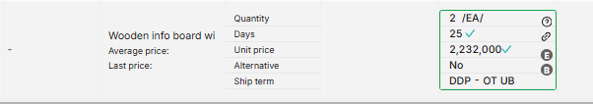
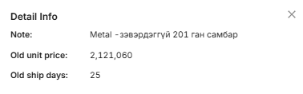

🔎 Please check out your ProcurementNow ticket status Pnow_v2 - Power BI here.
🧮 Need to know a responsible purchase officer for your SAP PR? PR - EU PR assignment - Power BI

Thanks.

Mendsaikhan
Officer - Purchasing | Procurement
M +976 99076319
From: Bayarjargal Baigalimaa (OT) <bayarjargalba@ot.mn>
Sent: Friday, May 15, 2026 3:58 PM
To: Mendsaikhan Munkhnasan (OT) <MendsaikhanMun@ot.mn>; OT OASIS SUPPORT (OT) <oasissupport@ot.mn>; Nandin-Erdene Chuluunbat (OT-UGUUMURGAVILUUD) <Nandin-ErdeneC@ot.mn>
Cc: OT Procurement Purchasing Team <OTProcurementPurchasingTeam@ot.mn>
Subject: RE: Oasis bug fix

Hi team,

End user neg item deer olon supplier songood suggestion yavuulj bgaag zasaad negiig l songodog bolgood ugnu uu. thgui bolhoor ene 3iihaa yag alinaas avmaar bgaag ergej lavlah, songoltii ni zasuulah geed davhar ajil bolood bgaa yum. thanks

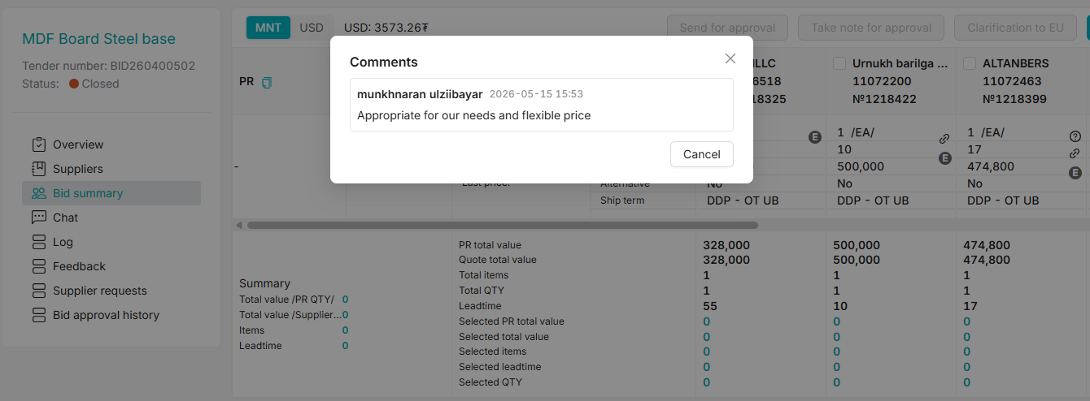

Best,
Byra
🔎⁠Please visit here to see any Pnow ticket status; or
🧮⁠Please visit here to find who is working on your PR
From: OT OASIS SUPPORT (OT) <oasissupport@ot.mn>
Sent: Monday, May 18, 2026 11:58 AM
To: Bayarjargal Baigalimaa (OT) <bayarjargalba@ot.mn>; Mendsaikhan Munkhnasan (OT) <MendsaikhanMun@ot.mn>; Nandin-Erdene Chuluunbat (OT-UGUUMURGAVILUUD) <Nandin-ErdeneC@ot.mn>
Cc: OT Procurement Purchasing Team <OTProcurementPurchasingTeam@ot.mn>
Subject: RE: Oasis bug fix

Dear Byra egch,

Cntl+Shift+R daraad shalgaad uzdee,

Sincerely,
Nandin
From: Bayarjargal Baigalimaa (OT) <bayarjargalba@ot.mn>
Sent: Tuesday, May 19, 2026 3:15 PM
To: OT OASIS SUPPORT (OT) <oasissupport@ot.mn>; Mendsaikhan Munkhnasan (OT) <MendsaikhanMun@ot.mn>; Nandin-Erdene Chuluunbat (OT-UGUUMURGAVILUUD) <Nandin-ErdeneC@ot.mn>
Cc: OT Procurement Purchasing Team <OTProcurementPurchasingTeam@ot.mn>
Subject: RE: Oasis bug fix

Hi NAndia,

Thanks for the reply. Here is another example of choosing multiple suppliers and entered same comment from end user. How to know which supplier end user has selected?

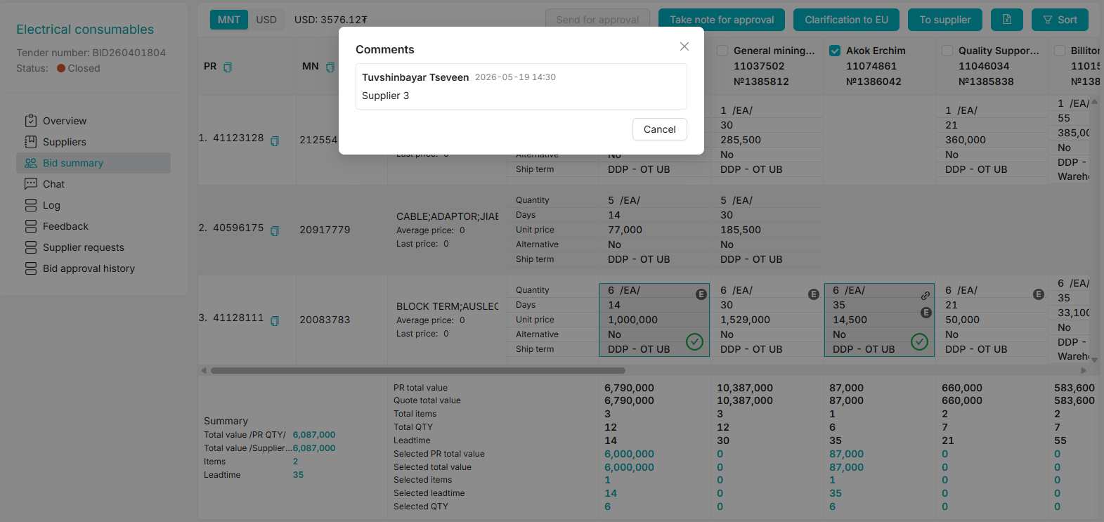

Best,
Byra
🔎⁠Please visit here to see any Pnow ticket status; or
🧮⁠Please visit here to find who is working on your PR
From: Bayarjargal Baigalimaa (OT) <bayarjargalba@ot.mn>
Sent: Tuesday, May 19, 2026 3:50 PM
To: OT OASIS SUPPORT (OT) <oasissupport@ot.mn>; Mendsaikhan Munkhnasan (OT) <MendsaikhanMun@ot.mn>; Nandin-Erdene Chuluunbat (OT-UGUUMURGAVILUUD) <Nandin-ErdeneC@ot.mn>
Cc: OT Procurement Purchasing Team <OTProcurementPurchasingTeam@ot.mn>
Subject: RE: Oasis bug fix

Another question:

Ene bid gadnaasaa harahaar end user ni songoltoo hiitsiim shig atlaa dotor ni orood harahaar yamar ch songolt hiigeegui bh yum. ene 2 medeelliin ali ni zuv be?

Gadnaasaa:
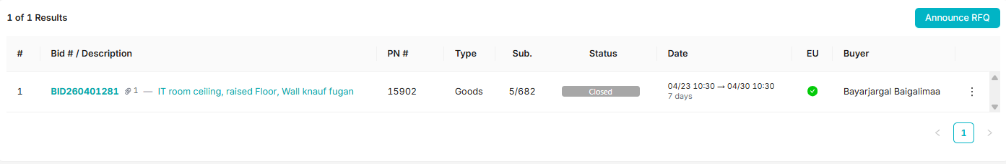

Dotor ni:
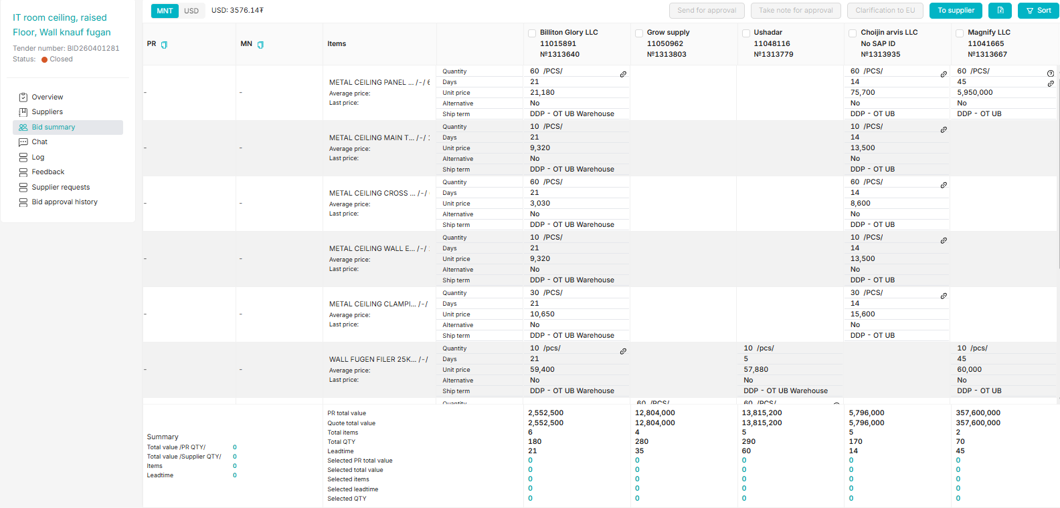
Best,
Byra
🔎⁠Please visit here to see any Pnow ticket status; or
🧮⁠Please visit here to find who is working on your PR
From: Bayarjargal Baigalimaa (OT) <bayarjargalba@ot.mn>
Sent: Tuesday, May 19, 2026 4:55 PM
To: OT OASIS SUPPORT (OT) <oasissupport@ot.mn>; Mendsaikhan Munkhnasan (OT) <MendsaikhanMun@ot.mn>; Nandin-Erdene Chuluunbat (OT-UGUUMURGAVILUUD) <Nandin-ErdeneC@ot.mn>
Cc: OT Procurement Purchasing Team <OTProcurementPurchasingTeam@ot.mn>
Subject: RE: Oasis bug fix

Hi Nandia,

Doorh aldaa zaagaad tender zarlaj boldguiee, yamar ued iim aldaa gardag ve?

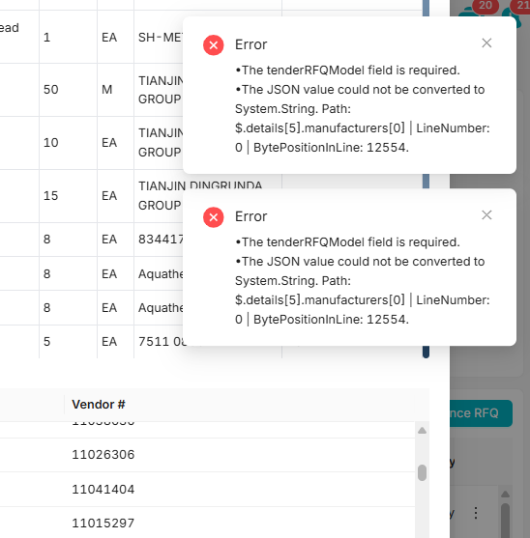

Best,
Byra
🔎⁠Please visit here to see any Pnow ticket status; or
🧮⁠Please visit here to find who is working on your PR
From: OT OASIS SUPPORT (OT) <oasissupport@ot.mn>
Sent: Tuesday, May 19, 2026 5:29 PM
To: Bayarjargal Baigalimaa (OT) <bayarjargalba@ot.mn>; Mendsaikhan Munkhnasan (OT) <MendsaikhanMun@ot.mn>; Nandin-Erdene Chuluunbat (OT-UGUUMURGAVILUUD) <Nandin-ErdeneC@ot.mn>
Cc: OT Procurement Purchasing Team <OTProcurementPurchasingTeam@ot.mn>
Subject: RE: Oasis bug fix

Dear Byra egch,

Tomoor ni SS hiigeed ugnu uu. Manifacture name deer ni uur utga bhshg baina.

Sincerely,
OASIS Team
Contact: +976 75 778 800, Ext: 8888


From: Bayarjargal Baigalimaa (OT) <bayarjargalba@ot.mn>
Sent: Tuesday, May 19, 2026 5:35 PM
To: OT OASIS SUPPORT (OT) <oasissupport@ot.mn>; Mendsaikhan Munkhnasan (OT) <MendsaikhanMun@ot.mn>; Nandin-Erdene Chuluunbat (OT-UGUUMURGAVILUUD) <Nandin-ErdeneC@ot.mn>
Cc: OT Procurement Purchasing Team <OTProcurementPurchasingTeam@ot.mn>
Subject: RE: Oasis bug fix

Here you go 😊
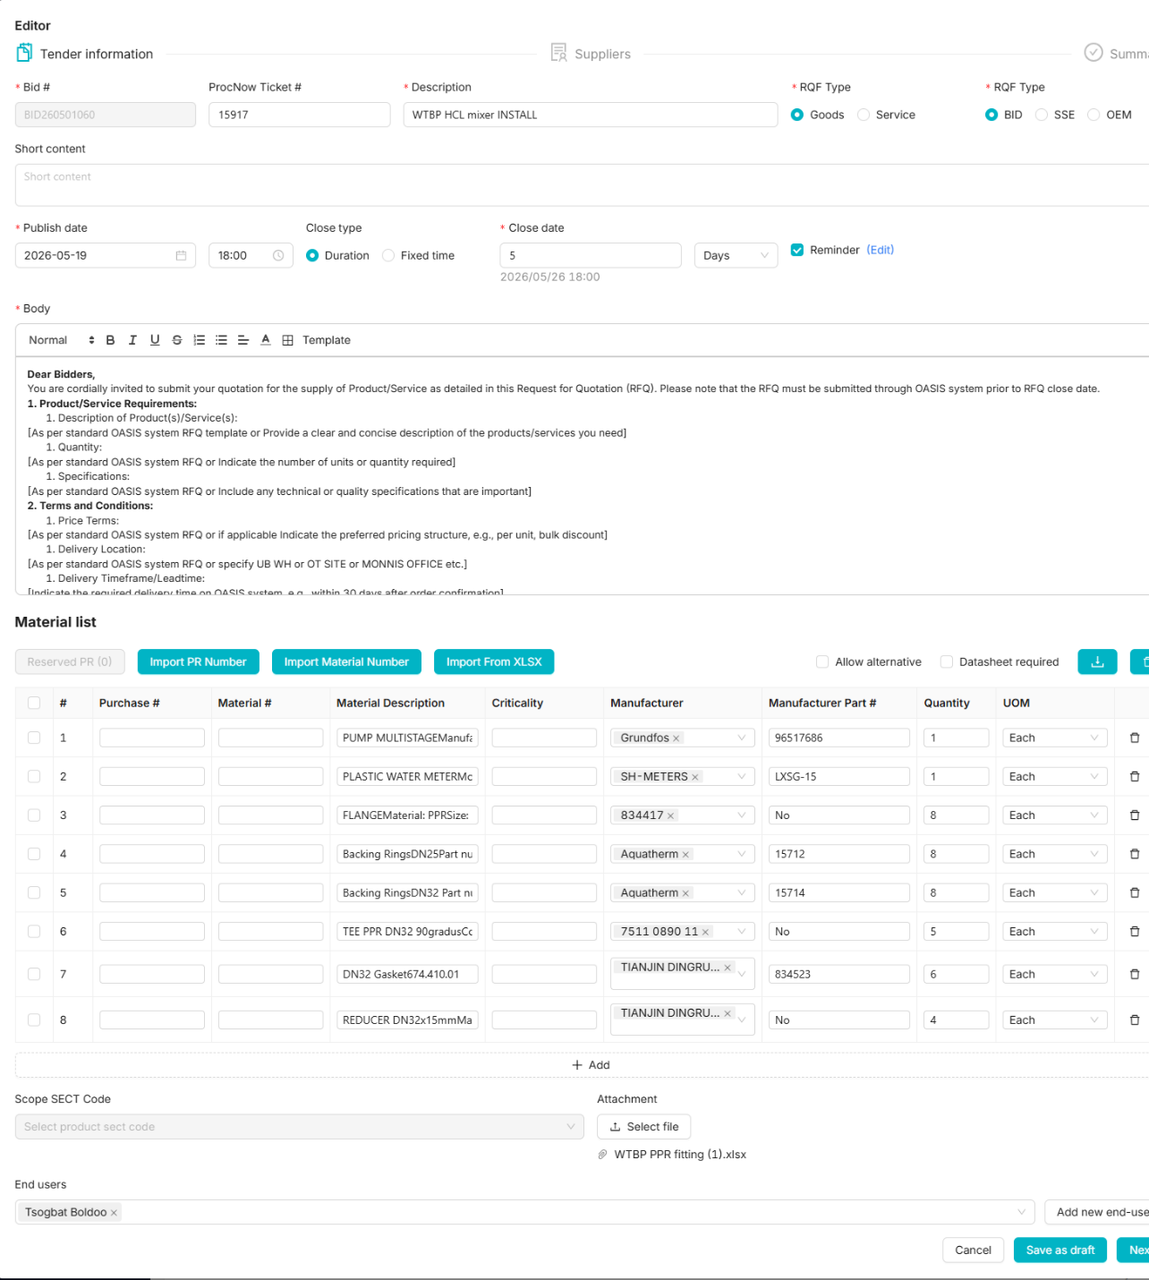

Best,
Byra
🔎⁠Please visit here to see any Pnow ticket status; or
🧮⁠Please visit here to find who is working on your PR
From: Nandin-Erdene Chuluunbat (OT-UGUUMURGAVILUUD) <Nandin-ErdeneC@ot.mn>
Sent: Wednesday, May 20, 2026 9:05 AM
To: Bayarjargal Baigalimaa (OT) <bayarjargalba@ot.mn>; OT OASIS SUPPORT (OT) <oasissupport@ot.mn>; Mendsaikhan Munkhnasan (OT) <MendsaikhanMun@ot.mn>
Cc: OT Procurement Purchasing Team <OTProcurementPurchasingTeam@ot.mn>
Subject: RE: Oasis bug fix

Ugluunii mend,

Manufacturer name deeree toon utga baigaag ni zasval asuudal processlogdohoor bainaa.

Sincerely,
Nandin
From: Yanjindulam Baasanjav (OT) <YanjindulamB@ot.mn>
Sent: Thursday, May 21, 2026 5:38 PM
To: Nandin-Erdene Chuluunbat (OT-UGUUMURGAVILUUD) <Nandin-ErdeneC@ot.mn>; OT OASIS SUPPORT (OT) <oasissupport@ot.mn>
Cc: OT Procurement Purchasing Team <OTProcurementPurchasingTeam@ot.mn>
Subject: RE: Oasis bug fix

Hi Nandia,

BID 1 participated uyed SSR-n DFA approvalaar yavdag bolson chin, OEM maani dagaad uurchlugdchihejee. OEM-iig huuchnaar bolgood uguurei

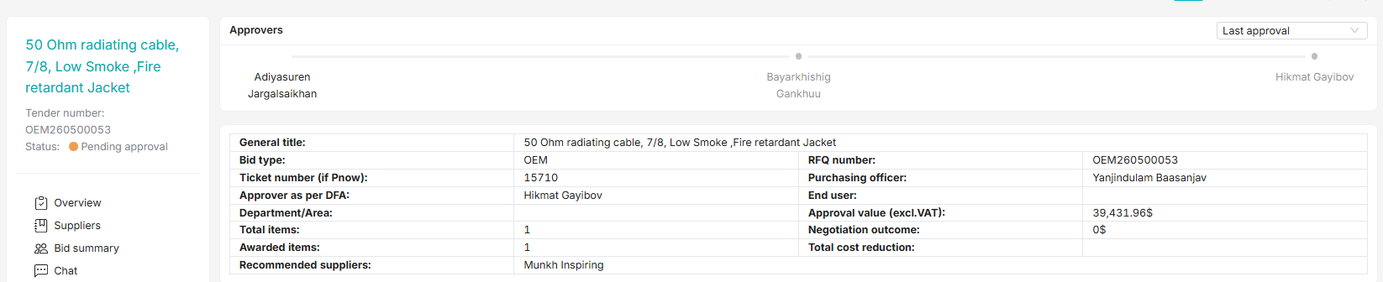

BR, Yanja
From: Bayarjargal Baigalimaa (OT) <bayarjargalba@ot.mn>
Sent: Tuesday, June 2, 2026 5:34 PM
To: Yanjindulam Baasanjav (OT) <YanjindulamB@ot.mn>; Nandin-Erdene Chuluunbat (OT-UGUUMURGAVILUUD) <Nandin-ErdeneC@ot.mn>; OT OASIS SUPPORT (OT) <oasissupport@ot.mn>
Cc: OT Procurement Purchasing Team <OTProcurementPurchasingTeam@ot.mn>
Subject: RE: Oasis bug fix

Hi team,

Approval huleej bgaa bid-nuudee hen deer approval pending bgaag ni ene buyer gesen nernii orond harj bolhu? Bid uursdiihuu neriig harsnaas iluutei hen deer tuhain huselt maani huleegdej bgaag harah ni iluu heregtei bgaa yum. thanks

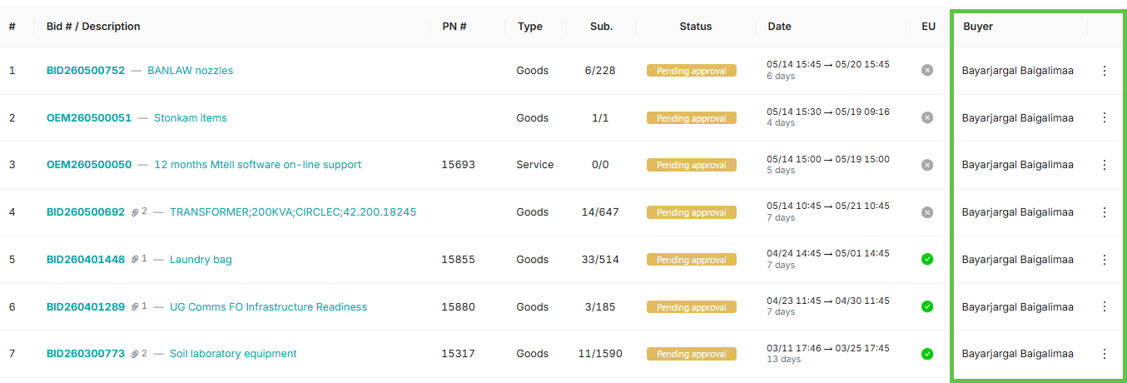

Best,
Byra
🔎⁠If you would like to know your Pnow ticket status, please visit here; if PR please check from here.
From: Bayarjargal Baigalimaa (OT) <bayarjargalba@ot.mn>
Sent: Wednesday, June 3, 2026 3:40 PM
To: Yanjindulam Baasanjav (OT) <YanjindulamB@ot.mn>; Nandin-Erdene Chuluunbat (OT-UGUUMURGAVILUUD) <Nandin-ErdeneC@ot.mn>; OT OASIS SUPPORT (OT) <oasissupport@ot.mn>
Cc: OT Procurement Purchasing Team <OTProcurementPurchasingTeam@ot.mn>
Subject: RE: Oasis bug fix

Hi team,

Ene bid end user ni review hiitsen geed bgaa bolovch neegeed harhaar yamar E usegtei supplier bdgui. Dahiad review hiigeed yavuulaach gesen chin tiim option bhgui bna genee. Uuniig shalgaad ugnu uu. thanks

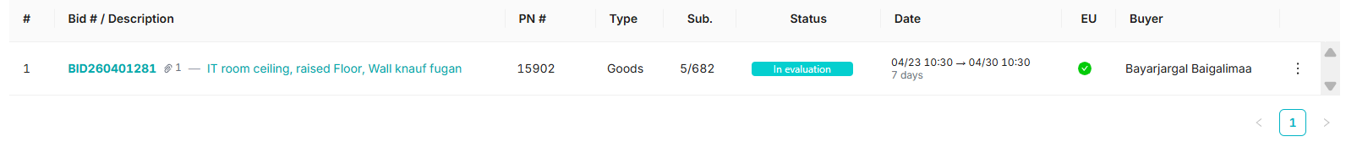

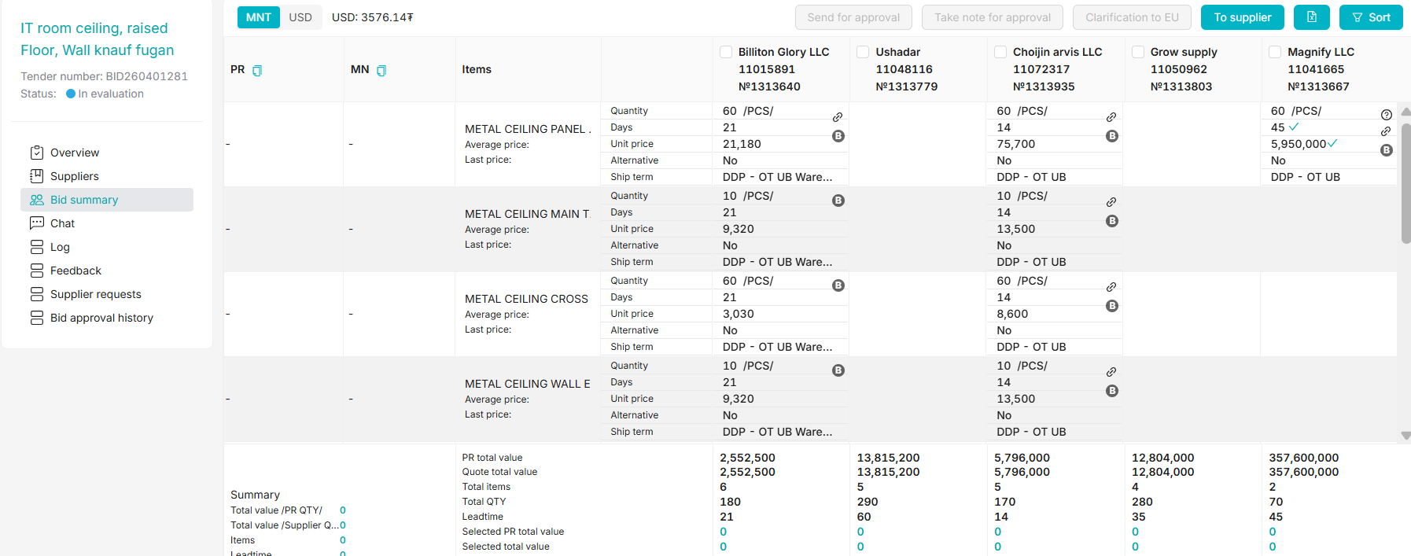

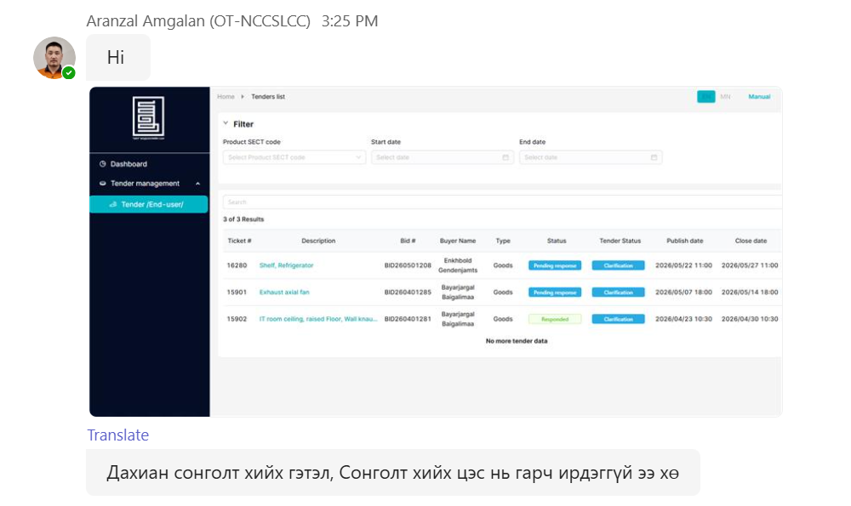
Best,
Byra
🔎⁠If you would like to know your Pnow ticket status, please visit here; if PR please check from here.
From: Bayarjargal Baigalimaa (OT) <bayarjargalba@ot.mn>
Sent: Wednesday, July 1, 2026 9:36 AM
To: Yanjindulam Baasanjav (OT) <YanjindulamB@ot.mn>; OT OASIS SUPPORT (OT) <oasissupport@ot.mn>; Zaya Bolorbat (OT) <ZayaB@ot.mn>; Khulan Davaadorj (OT) <Khulan.Davaadorj@riotinto.com>
Cc: OT Procurement Purchasing Team <OTProcurementPurchasingTeam@ot.mn>; Nandin-Erdene Chuluunbat (OT-UGUUMURGAVILUUD) <Nandin-ErdeneC@ot.mn>
Subject: RE: Oasis bug fix

Hi oasis team,

Ene tender deer end user ni daraah 2 item deer songolt hiigeegui gej nadad haragdaj bgaa ch end user deeree bolhoor bugdii ni songoson gej haragdaad bgaag zasch ugnu uu.

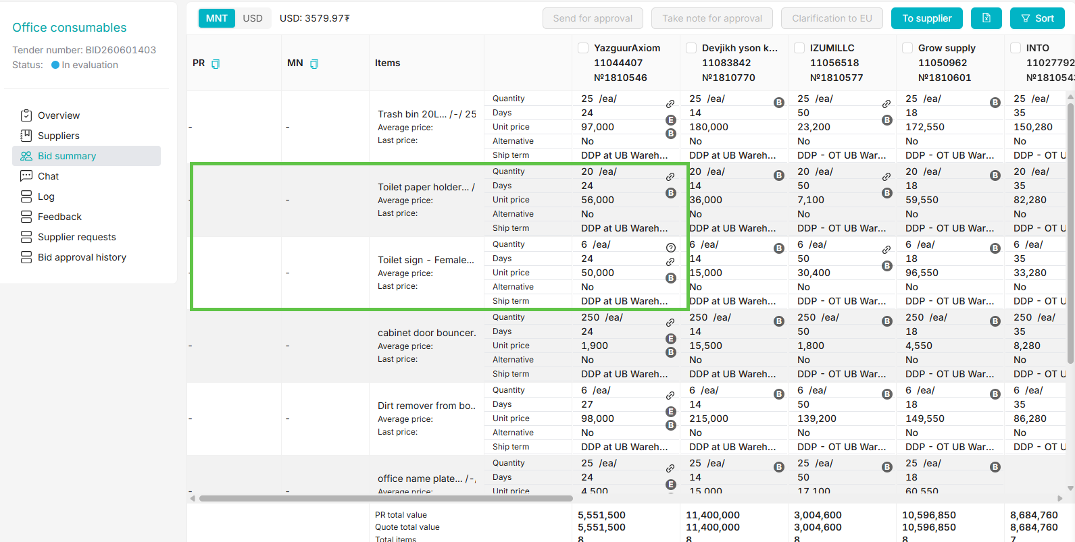

End usertee ingej haragdag bgaa:
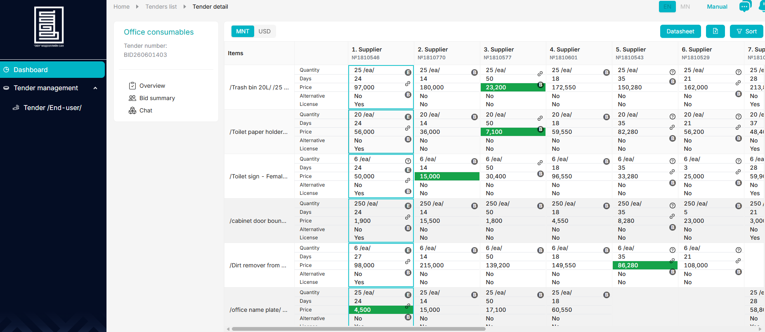

Best,
Byra
🔎⁠If you would like to know your Pnow ticket status, please visit here; if PR please check from here.
From: Bayarjargal Baigalimaa (OT) <bayarjargalba@ot.mn>
Sent: Monday, July 6, 2026 4:52 PM
To: OT OASIS SUPPORT (OT) <oasissupport@ot.mn>; Zaya Bolorbat (OT) <ZayaB@ot.mn>; Khulan Davaadorj (OT) <Khulan.Davaadorj@riotinto.com>
Cc: OT Procurement Purchasing Team <OTProcurementPurchasingTeam@ot.mn>; Yanjindulam Baasanjav (OT) <YanjindulamB@ot.mn>; Nandin-Erdene Chuluunbat (OT-UGUUMURGAVILUUD) <Nandin-ErdeneC@ot.mn>
Subject: RE: Oasis bug fix

Hi team,

Suuliin ued end user yagaad tuhain supplieriig songoj bui ni haragdku iim blank suggestions ireed bgaa. Eniig zaaval yum bichij ilgeedeg bolgoj ugnu uu. esvel bichsen yum ni haragdku bolchood bnu?

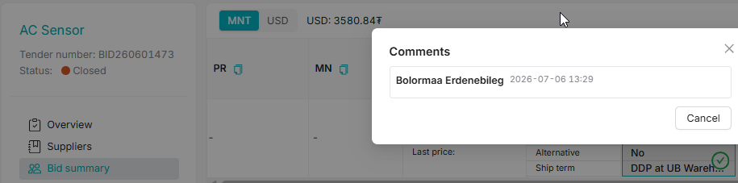

Best,
Byra
🔎⁠If you would like to know your Pnow ticket status, please visit here; if PR please check from here.
From: Bayarjargal Baigalimaa (OT) <bayarjargalba@ot.mn>
Sent: Monday, August 10, 2026 3:19 PM
To: OT OASIS SUPPORT (OT) <oasissupport@ot.mn>; Zaya Bolorbat (OT) <ZayaB@ot.mn>; Khulan Davaadorj (OT) <Khulan.Davaadorj@riotinto.com>; Nandin-Erdene Chuluunbat (OT-UGUUMURGAVILUUD) <Nandin-ErdeneC@ot.mn>
Cc: OT Procurement Purchasing Team <OTProcurementPurchasingTeam@ot.mn>; Yanjindulam Baasanjav (OT) <YanjindulamB@ot.mn>; Duke, Josephine (GBS) <Josephine.Duke@riotinto.com>
Subject: RE: Oasis bug fix

Hi team,

Below RFQ is for actually 29M MNT but Oasis shows it is for 29M USD and requires following approval and DD etc. It’s the fourth time I am facing the same bug, then can you please fix it once for all?

Tender number: BID260700385
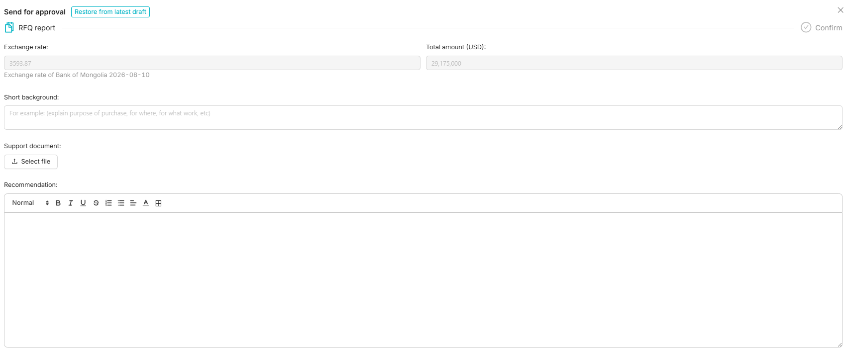

Best,
Byra
🔎⁠If you would like to know your Pnow ticket status, please visit here; if PR please check from here.
From: OT OASIS SUPPORT (OT) <oasissupport@ot.mn>
Sent: Monday, August 10, 2026 4:12 PM
To: Bayarjargal Baigalimaa (OT) <bayarjargalba@ot.mn>; Zaya Bolorbat (OT) <ZayaB@ot.mn>; Khulan Davaadorj (OT) <Khulan.Davaadorj@riotinto.com>; Nandin-Erdene Chuluunbat (OT-UGUUMURGAVILUUD) <Nandin-ErdeneC@ot.mn>
Cc: OT Procurement Purchasing Team <OTProcurementPurchasingTeam@ot.mn>; Yanjindulam Baasanjav (OT) <YanjindulamB@ot.mn>; Duke, Josephine (GBS) <Josephine.Duke@riotinto.com>
Subject: Re: Oasis bug fix

Dear Byra,

The issue with the bid has been corrected, and we apologize for any inconvenience this may have caused while using the system.
We are fully aware of this issue, and a permanent fix is planned for Phase 2 of the system development.
In the meantime, we are working to identify a workaround until the permanent solution is implemented.

Thanks,
Zaya
From: Ariunbolor Khuyagbaatar (OT) <AriunbolorK@ot.mn>
Sent: Tuesday, August 11, 2026 4:45 PM
To: OT OASIS SUPPORT (OT) <oasissupport@ot.mn>; Zaya Bolorbat (OT) <ZayaB@ot.mn>; Khulan Davaadorj (OT) <Khulan.Davaadorj@riotinto.com>; Nandin-Erdene Chuluunbat (OT-UGUUMURGAVILUUD) <Nandin-ErdeneC@ot.mn>
Cc: OT Procurement Purchasing Team <OTProcurementPurchasingTeam@ot.mn>; Duke, Josephine (GBS) <Josephine.Duke@riotinto.com>
Subject: RE: Oasis bug fix

Hi team,

I am facing the same issue as mentioned below. Could you please assist in resolving it?

In MNT:
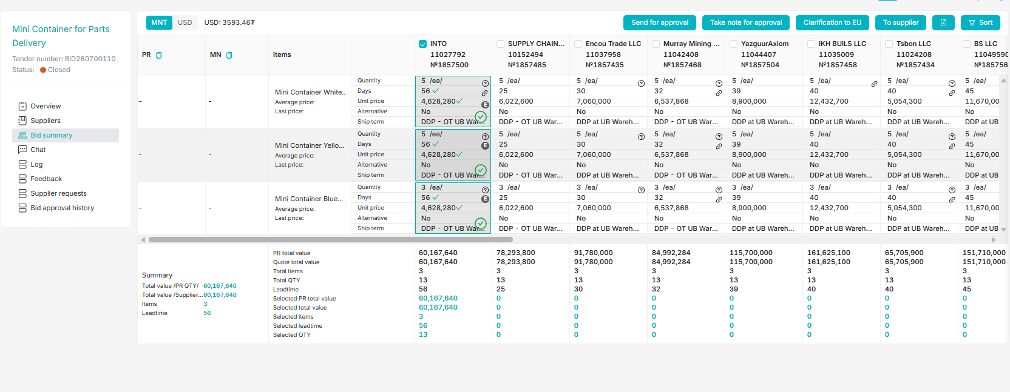

In USD:
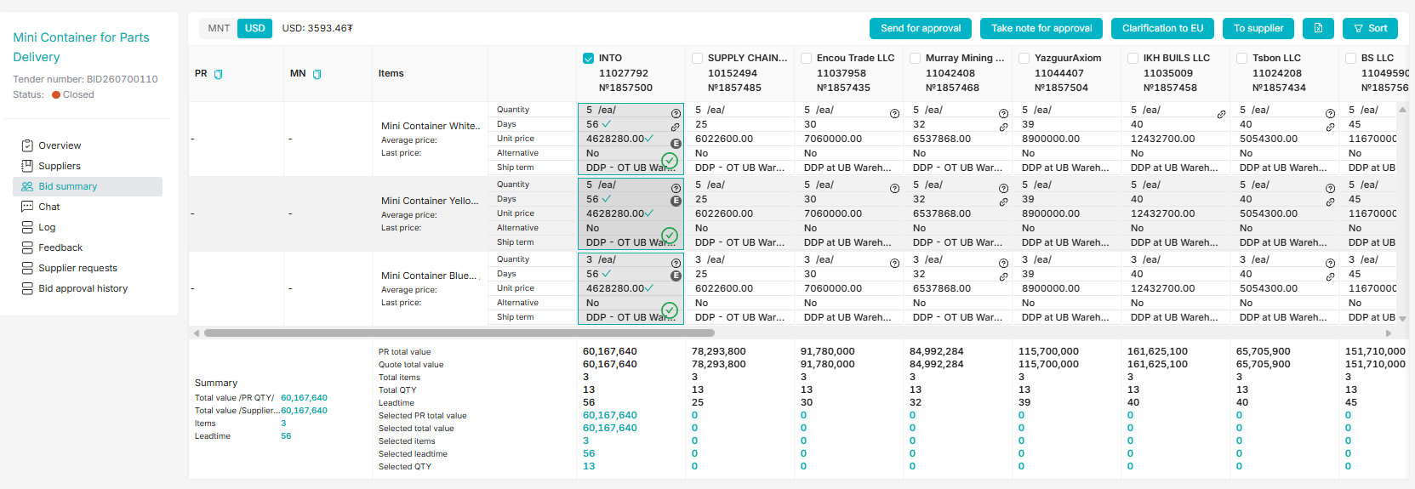

Regards,
Ariuka

|Analyst Purchasing |Oyu Tolgoi LLC, Managed by RioTinto|
|Tel:+976-11-331880;Ext=7513|Fax:|Cell:+976-99905176|
EMAIL:Ariunbolork@ot.mn

Please use this link to see any Pnow ticket status🔎 ProcurementNow ticket status search
Please use this link to find PR assignments 🧮 SAP PR distribution status Click here
From: Sergelen Badarch (OT) <SergelenB@ot.mn>
Sent: Wednesday, August 12, 2026 3:19 PM
To: Ariunbolor Khuyagbaatar (OT) <AriunbolorK@ot.mn>; OT OASIS SUPPORT (OT) <oasissupport@ot.mn>; Zaya Bolorbat (OT) <ZayaB@ot.mn>; Khulan Davaadorj (OT) <Khulan.Davaadorj@riotinto.com>; Nandin-Erdene Chuluunbat (OT-UGUUMURGAVILUUD) <Nandin-ErdeneC@ot.mn>
Cc: OT Procurement Purchasing Team <OTProcurementPurchasingTeam@ot.mn>; Duke, Josephine (GBS) <Josephine.Duke@riotinto.com>
Subject: RE: Oasis bug fix

Hi dears,

Can you check this tender? What caused these many variations of quotation? Both suppliers submitted more than ten times variations of quotes with same amount.

BID260701041

BR,
Sergelen
From: OT OASIS SUPPORT (OT) <oasissupport@ot.mn>
Sent: Thursday, August 13, 2026 2:46 PM
To: Sergelen Badarch (OT) <SergelenB@ot.mn>; Ariunbolor Khuyagbaatar (OT) <AriunbolorK@ot.mn>; Zaya Bolorbat (OT) <ZayaB@ot.mn>; Khulan Davaadorj (OT) <Khulan.Davaadorj@riotinto.com>
Cc: OT Procurement Purchasing Team <OTProcurementPurchasingTeam@ot.mn>; Duke, Josephine (GBS) <Josephine.Duke@riotinto.com>
Subject: RE: Oasis bug fix

Hi Semka,

Suppliers sent several options of the proposal with same price and attached document to each option, see below SS, I hided the same proposed prices behind the Options#

The system was designed to have Price proposal options for the Service RFQ’s. Looks like suppliers used this option to attach separate files for the bid.

Please advise if we still need additional Options for Price proposal for Service Bids. If no need, we can remove the Options , if yes, we suggest to limit number of Options. What you think, please discus internally and let us know. Thank you . 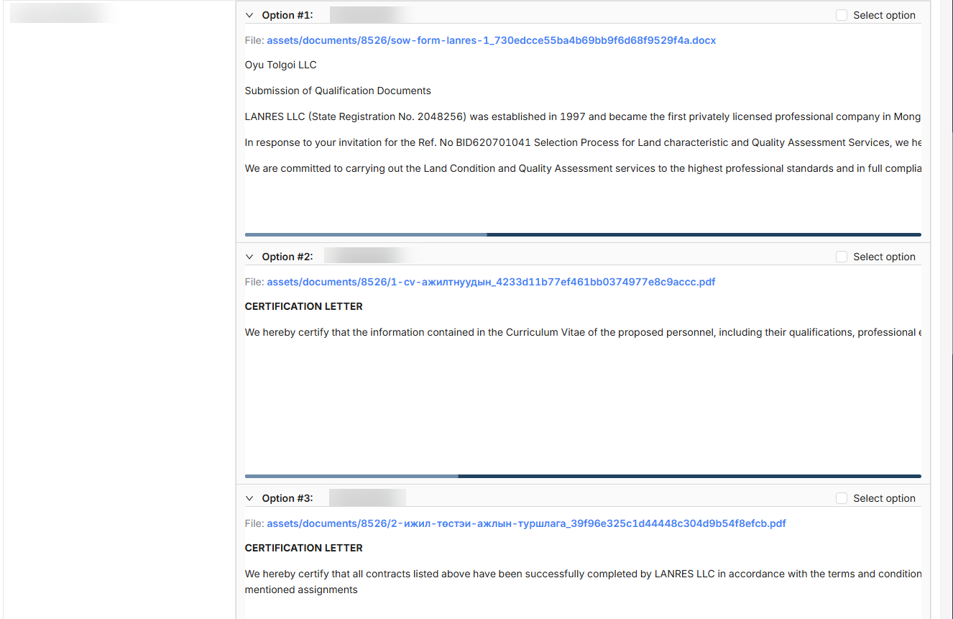

Regards,

Tuul
From: Mendsaikhan Munkhnasan (OT) <MendsaikhanMun@ot.mn>
Sent: Monday, August 17, 2026 9:02 AM
To: OT OASIS SUPPORT (OT) <oasissupport@ot.mn>; Sergelen Badarch (OT) <SergelenB@ot.mn>; Ariunbolor Khuyagbaatar (OT) <AriunbolorK@ot.mn>; Zaya Bolorbat (OT) <ZayaB@ot.mn>; Khulan Davaadorj (OT) <Khulan.Davaadorj@riotinto.com>
Cc: OT Procurement Purchasing Team <OTProcurementPurchasingTeam@ot.mn>; Duke, Josephine (GBS) <Josephine.Duke@riotinto.com>
Subject: RE: Oasis bug fix

Hi, OASIS team

Morning

We asked several times before, that needs line N0, 1,, in the bid sumarry. Specifically, if there are more than 10 line items, it wouldn’t fit in the screen and makes it difficult to work with. Can @Khulan Davaadorj (OT) advise when it will be implemented?

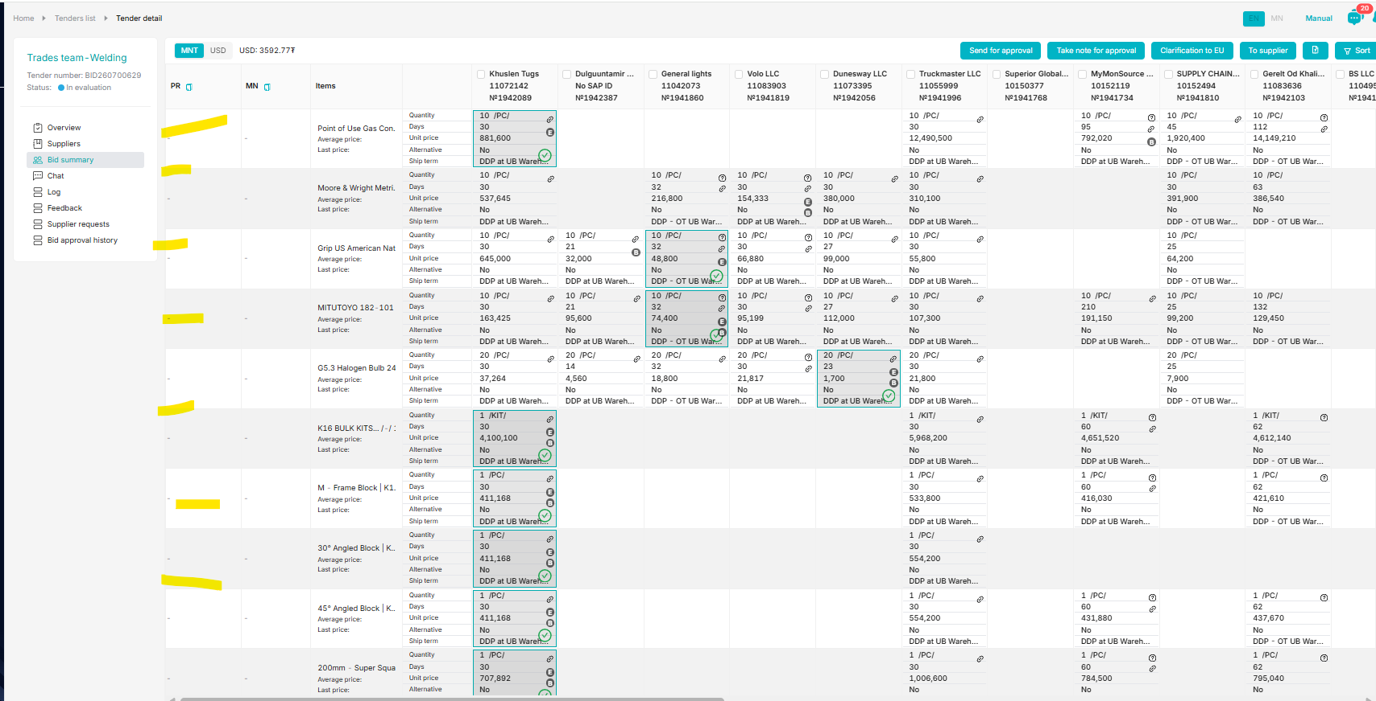

Thanks.

Mendsaikhan
Analyst - Purchasing | Procurement
M +976 99076319
From: Bayarjargal Baigalimaa (OT) <bayarjargalba@ot.mn>
Sent: Wednesday, August 19, 2026 3:41 PM
To: Mendsaikhan Munkhnasan (OT) <MendsaikhanMun@ot.mn>; OT OASIS SUPPORT (OT) <oasissupport@ot.mn>; Sergelen Badarch (OT) <SergelenB@ot.mn>; Ariunbolor Khuyagbaatar (OT) <AriunbolorK@ot.mn>; Zaya Bolorbat (OT) <ZayaB@ot.mn>; Khulan Davaadorj (OT) <Khulan.Davaadorj@riotinto.com>
Cc: OT Procurement Purchasing Team <OTProcurementPurchasingTeam@ot.mn>; Duke, Josephine (GBS) <Josephine.Duke@riotinto.com>
Subject: RE: Oasis bug fix

Hi team,

Another bug on Oasis is that non-partial sort doesn't work. Can you please fix it immediately?

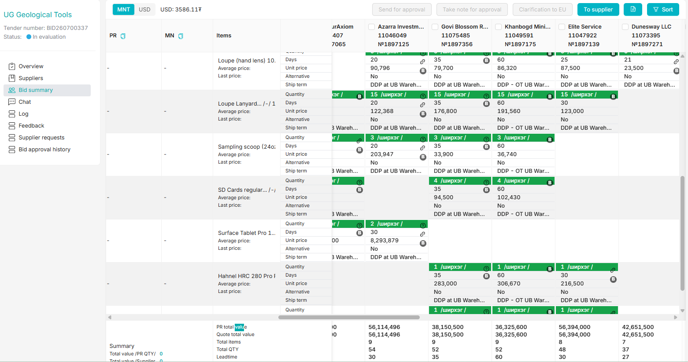

Regards,
Byra
🔎⁠If you would like to know your Pnow ticket status, please visit here; if PR please check from here.
Any specialized AI support needed for comprehensive SOW, please use Pengiun function linked here.
From: Bayarjargal Baigalimaa (OT) <bayarjargalba@ot.mn>
Sent: Wednesday, August 19, 2026 4:40 PM
To: Mendsaikhan Munkhnasan (OT) <MendsaikhanMun@ot.mn>; OT OASIS SUPPORT (OT) <oasissupport@ot.mn>; Sergelen Badarch (OT) <SergelenB@ot.mn>; Ariunbolor Khuyagbaatar (OT) <AriunbolorK@ot.mn>; Zaya Bolorbat (OT) <ZayaB@ot.mn>; Khulan Davaadorj (OT) <Khulan.Davaadorj@riotinto.com>
Cc: OT Procurement Purchasing Team <OTProcurementPurchasingTeam@ot.mn>; Duke, Josephine (GBS) <Josephine.Duke@riotinto.com>
Subject: RE: Oasis bug fix

Team,

This looks like the sort options do not work. I’d like to ask datasheet from suppliers on items without datasheet, but the selected sort doesn’t work at all. It is difficult to work on huge tables like below where on 13 items total 32 suppliers quoted. Thus, if the sort options work as they are supposed to, it helps make it simpler.

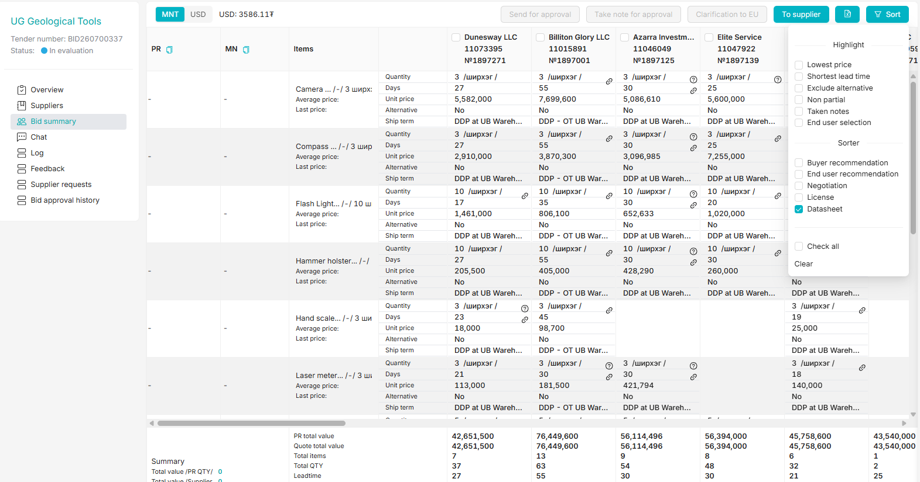

Regards,
Byra
🔎⁠If you would like to know your Pnow ticket status, please visit here; if PR please check from here.
Any specialized AI support needed for comprehensive SOW, please use Pengiun function linked here.
From: Bayarjargal Baigalimaa (OT)
Sent: Wednesday, August 26, 2026 2:55 PM
To: Mendsaikhan Munkhnasan (OT) <MendsaikhanMun@ot.mn>; OT OASIS SUPPORT (OT) <oasissupport@ot.mn>; Sergelen Badarch (OT) <SergelenB@ot.mn>; Ariunbolor Khuyagbaatar (OT) <AriunbolorK@ot.mn>; Zaya Bolorbat (OT) <ZayaB@ot.mn>; Khulan Davaadorj (OT) <Khulan.Davaadorj@riotinto.com>
Cc: OT Procurement Purchasing Team <OTProcurementPurchasingTeam@ot.mn>; Duke, Josephine (GBS) <Josephine.Duke@riotinto.com>
Subject: RE: Oasis bug fix

Hi team,

Can you please make the chat text box format is rich text at least? Due to its plain text format, information in table format looks like continuous text and makes no sense to suppliers.

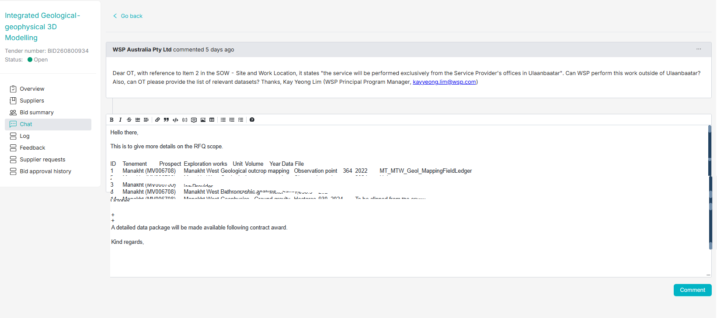

Regards,
Byra
🔎⁠If you would like to know your Pnow ticket status, please visit here; if PR please check from here.
Any specialized AI support needed for comprehensive SOW, please use Pengiun function linked here.
From: Bayarjargal Baigalimaa (OT) <bayarjargalba@ot.mn>
Sent: Wednesday, August 26, 2026 3:01 PM
To: Mendsaikhan Munkhnasan (OT) <MendsaikhanMun@ot.mn>; OT OASIS SUPPORT (OT) <oasissupport@ot.mn>; Sergelen Badarch (OT) <SergelenB@ot.mn>; Ariunbolor Khuyagbaatar (OT) <AriunbolorK@ot.mn>; Zaya Bolorbat (OT) <ZayaB@ot.mn>; Khulan Davaadorj (OT) <Khulan.Davaadorj@riotinto.com>
Cc: OT Procurement Purchasing Team <OTProcurementPurchasingTeam@ot.mn>; Duke, Josephine (GBS) <Josephine.Duke@riotinto.com>
Subject: RE: Oasis bug fix

Team,

I wanted to give the suppliers below information but it looks like shown on attached. What’s the best way to provide supporting details to suppliers during tender? Can you send below to the invited suppliers in better understanding format?

***
Hello there,

This is to give more details on the RFQ scope.

1. Site and Work Location
The services may be performed outside of Ulaanbaatar. The intent is that the work be undertaken remotely from the Service Provider's offices, provided that all contractual requirements, communication arrangements, confidentiality obligations, and deliverables are met in accordance with the requirements.
2. Relevant Datasets
The successful bidder will be provided with the datasets required to complete the scope of work. These include:

ID | Tenement | Prospect | Exploration works | Unit | Volume | Year | Data File
1 | Manakht (MV006708) | Manakht West | Geological outcrop mapping | Observation point | 364 | 2022 | MT_MTW_Geol_MappingFieldLedger
2 | Manakht (MV006708) | Manakht West | Geological outcrop mapping | Observation point | - | 2024 | Unknown
3 | Manakht (MV006708) | Manakht West | Structural field observation | Observation point | 42 | 2024 | MT_MTW_Geol_StructureFieldObserv
4 | Manakht (MV006708) | Manakht West | Pethrographic analysis | Sample | 12 | 2022 | 004_Mineralogy
5 | Manakht (MV006708) | Manakht West | Geochemistry rock-chip sampling | Sample | 36 |  | MT_MTW_Geoc_RocksampleAssayP
6 | Manakht (MV006708) | Manakht West | Geochemistry soil sampling | Sample | 841 | 2015 | MT_MTW_Geoc_SoilAssayP_2015
7 | Manakht (MV006708) | Manakht West | Geochronology/Age-dating | Sample | 4 | 2022 | MT_MTW_Geoc_GeochronSampleP
8 | Manakht (MV006708) | Manakht West | Diamond drilling | meter | 1,058.3 | 2024 | Drilling data (CSV spreadsheet: Collar, survey, lith, min, alt, structure, vein, multi-element assay data)
9 | Manakht (MV006708) | Manakht West | RC drilling | meter | 235 | 2018 | Drilling data (CSV spreadsheet: Collar, survey, lith, min, alt, structure, vein, multi-element assay data)
10 | Manakht (MV006708) | Whole tenement | Geophysics - Ground magnetic | Hectares | 930 | 2014 | Line spacing 50 - 25m - to be clipped from the original dataset including RAW data
11 | Manakht (MV006708) | Whole tenement | Geophysics - Ground gravity | Hectares | 930 | 2025 | Grid 100 x 100m - To be clipped from the original dataset including RAW data
12 | Manakht (MV006708) | Whole tenement | Geophysics - Gradient-array IP | Hectares | 930 | 2005 | To be clipped from the original dataset including RAW data
13 | Manakht (MV006708) | Manakht West | Geophysics - DDIP | Line.km | 3 | 2016 | To be clipped from the original dataset including RAW data
14 | Manakht (MV006708) | Manakht West | Geophysics - Ground gravity | Hectares | 930 | 2024 | To be clipped from the original dataset including RAW data

The RFQ doesn’t specifically mention processing of the geophysical datasets, or completion of unconstrained or constrained geophysical modelling.
RAW data processing and uncontrained/contrained geophysical modelling are expected as part of the service.

The timeline is stated in the relevant SOW:

Milestones | August |  | September |  | October
 | 1st half | 2nd half | 1st half | 2nd half | 1st half | 2nd half
Tendering & Selection of Service Provider |  | +
Data Transfer |  |  | +
Technical Work Execution by the selected Service Provider |  |  |  | + | +
Final Deliverables Submission & Handover |  |  |  |  |  | +

A detailed data package will be made available following contract award.

Kind regards,
Oyu Tolgoi LLC
***

Regards,
Byra
🔎⁠If you would like to know your Pnow ticket status, please visit here; if PR please check from here.
Any specialized AI support needed for comprehensive SOW, please use Pengiun function linked here.
From: OT OASIS SUPPORT (OT) <oasissupport@ot.mn>
Sent: Thursday, August 27, 2026 10:44 AM
To: Bayarjargal Baigalimaa (OT) <bayarjargalba@ot.mn>; Mendsaikhan Munkhnasan (OT) <MendsaikhanMun@ot.mn>; Sergelen Badarch (OT) <SergelenB@ot.mn>; Ariunbolor Khuyagbaatar (OT) <AriunbolorK@ot.mn>; Zaya Bolorbat (OT) <ZayaB@ot.mn>; Khulan Davaadorj (OT) <Khulan.Davaadorj@riotinto.com>
Cc: OT Procurement Purchasing Team <OTProcurementPurchasingTeam@ot.mn>; Duke, Josephine (GBS) <Josephine.Duke@riotinto.com>
Subject: Re: Oasis bug fix

Dear Byra,

You may now upload attachment to the tender and please let us know once you complete attaching the document to the bid.
Also, we would like to let you know that chat functionality could be implemented in phase 2 of the Oasis development, however, we need to conduct internal discussion regarding the change since the change need to consider Cyber Security team's recommendations.

Thanks,
Zaya
From: Bayarjargal Baigalimaa (OT) <bayarjargalba@ot.mn>
Sent: Thursday, August 27, 2026 11:01 AM
To: OT OASIS SUPPORT (OT) <oasissupport@ot.mn>; Mendsaikhan Munkhnasan (OT) <MendsaikhanMun@ot.mn>; Sergelen Badarch (OT) <SergelenB@ot.mn>; Ariunbolor Khuyagbaatar (OT) <AriunbolorK@ot.mn>; Zaya Bolorbat (OT) <ZayaB@ot.mn>; Khulan Davaadorj (OT) <Khulan.Davaadorj@riotinto.com>
Cc: OT Procurement Purchasing Team <OTProcurementPurchasingTeam@ot.mn>; Duke, Josephine (GBS) <Josephine.Duke@riotinto.com>
Subject: RE: Oasis bug fix

Hi dear,

Thank you so much for helping resolve the issues.

Regards,
Byra
🔎⁠If you would like to know your Pnow ticket status, please visit here; if PR please check from here.
Any specialized AI support needed for comprehensive SOW, please use Pengiun function linked here.
From: Bayarjargal Baigalimaa (OT) <bayarjargalba@ot.mn>
Sent: Thursday, August 27, 2026 1:25 PM
To: OT OASIS SUPPORT (OT) <oasissupport@ot.mn>; Mendsaikhan Munkhnasan (OT) <MendsaikhanMun@ot.mn>; Sergelen Badarch (OT) <SergelenB@ot.mn>; Ariunbolor Khuyagbaatar (OT) <AriunbolorK@ot.mn>; Zaya Bolorbat (OT) <ZayaB@ot.mn>; Khulan Davaadorj (OT) <Khulan.Davaadorj@riotinto.com>
Cc: OT Procurement Purchasing Team <OTProcurementPurchasingTeam@ot.mn>; Duke, Josephine (GBS) <Josephine.Duke@riotinto.com>
Subject: RE: Oasis bug fix

Hi team,

However end user selected 4 items it looks like they selected only 2 of them. When I reconfirmed with end user, they said they need all 4 items.
This bid requires further approval, then can you please fix and show what’s their justification for all 4 items?

Buyer’s view:

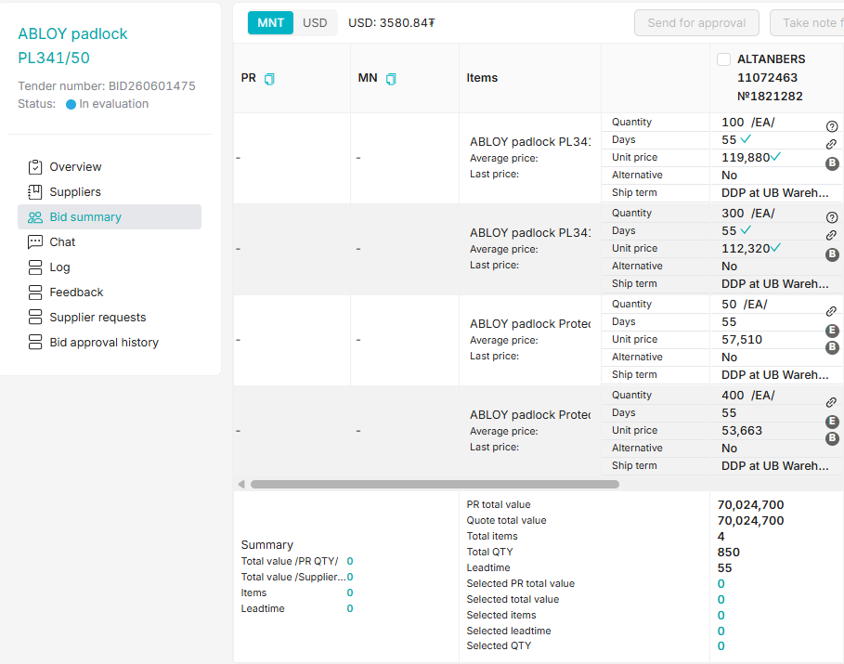

End user’s view:
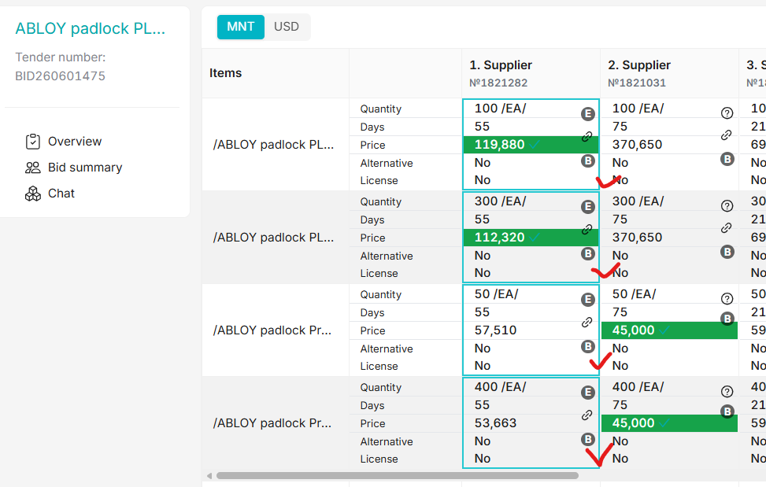

Regards,
Byra
🔎⁠If you would like to know your Pnow ticket status, please visit here; if PR please check from here.
Any specialized AI support needed for comprehensive SOW, please use Pengiun function linked here.
OT OASIS SUPPORT (OT)<oasissupport@ot.mn>
You
Khulan Davaadorj (OT);Zaya Bolorbat (OT)
Dear Temuujin,

Please advise on below request status, we sent it on August 27.

We were expecting to have update on the system last week to resolve this and similar EU selection issues.

Has this been completed? This is ongoing bid , so your attention is highly appreciated.

Look forward for your soonest response.

Thank you.

Enkhtuul
OT OASIS SUPPORT (OT)<oasissupport@ot.mn>
You
Zaya Bolorbat (OT);Khulan Davaadorj (OT)
Rio Tinto Confidential / Rio Tinto Confidentiel

Hi Temuujin,

Please check below issue on BID260800926 and resolve it ASAP as need to be sent for approval today.

Looks like the USD conversion has failed and the initial proposal in MNT shows as USD.

Regards,

OT Oasis team

Rio Tinto Confidential / Rio Tinto Confidentiel
From: Bayarjargal Baigalimaa (OT) <bayarjargalba@ot.mn>
Sent: Monday, August 31, 2026 11:28 AM
To: OT OASIS SUPPORT (OT) <oasissupport@ot.mn>; Zaya Bolorbat (OT) <ZayaB@ot.mn>; Khulan Davaadorj (OT) <Khulan.Davaadorj@riotinto.com>
Cc: OT Procurement Purchasing Team <OTProcurementPurchasingTeam@ot.mn>; Duke, Josephine (GBS) <Josephine.Duke@riotinto.com>; Ariunbolor Khuyagbaatar (OT) <AriunbolorK@ot.mn>; Sergelen Badarch (OT) <SergelenB@ot.mn>; Mendsaikhan Munkhnasan (OT) <MendsaikhanMun@ot.mn>
Subject: RE: Oasis bug fix

Hi team,

Same error with the currency occurred on below RFQ. Can you please quickly fix?

Regards,
Byra
🔎⁠If you would like to know your Pnow ticket status, please visit here; if PR please check from here.
Any specialized AI support needed for comprehensive SOW, please use Pengiun function linked here.

